Dr. Rick & Liz Kendall, Founder

Descriptions of the workings & outcomes of this seminar class.

Interactive

Dialogue

Discovery

Researching

Revelation

Transition

Process

Potential

Activation

Change

Welcome to the DESTINY GROUP MENTOR SCHOOL
Email: drrickkendall@outlook.com Phone: 772-979-3409
Course Series: The Constitution of God’s Kingdom
Final Test

Name__________________________ Score________________

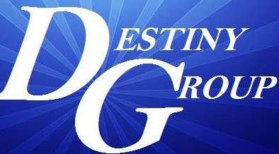

Questions will be in the form of True or False, Multiple Choice, Fill in the blank

- True or False: The Word of the King becomes the Law of the land. T__ F__

- Multiple Choice (chose one): We went from LAW regulation (under it) revealing sin to
- Grace needing no more LAW
- LAW principle (in us) revealing our original blueprint
- None of the above

- Fill in the blank: The Word of the King is Law & There is No ________ Without That Law Living In Us

- True or False: The SYSTEMS of this current world are ANTI-CHRIST (Anti-Religion) T__ F__

- Fill in the blank: Malachi 3:10 PROVE ME NOW and see if I will _________ YOU to be my windows.

- True or False: It’s what we do that produces our wealth, but it is not our wealth that produces what we do. T__ F__

- Multiple Choice (chose one): Man does not ORDAIN, but
- Experience activates ordination.
- God chooses those who are gifted.
- God sets authority in offices to recognize who God has ordained.

- True or False: Some of the factors that confirm your ordained purpose are positions & titles. T__ F__

- Fill in the blank: The Holy Spirit is not a dove, but _________________ LIKE a DOVE

- Multiple Choice (chose one): Psalm 3:3, But thou, O Lord, art
- A retreat for me to help me escape the enemy.
- A shield for me; my glory, and the lifter up of mine head.
- A rock of offence to those who those who believe.

Bonus Question:

- True or False: Hosanna 3:16, He shall cover thee with his feathers (pinions-strength), and under his wings (extension for flight) T__ F_

