Dr. Rick & Liz Kendall, Founder

Descriptions of the workings & outcomes of this seminar class.

Interactive

Dialogue

Discovery

Researching

Revelation

Transition

Process

Potential

Activation

Change

Welcome to the DESTINY GROUP MENTOR SCHOOL
Email: drrickkendall@outlook.com Phone: 772-979-3409
Course Series: The Constitution of God’s Kingdom

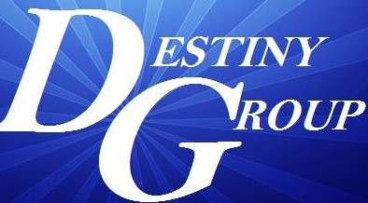
Study Sheet for Final Test

Questions will be in the form of True or False, Multiple Choice, Fill in the blank, and Match the definition

- The Word of the King becomes the Law of the land.

- We went from From LAW regulation (under it) revealing sin to LAW principle (in us) revealing our original blueprint

- The Word of the King is Law & There is No Grace Without That Law Living In Us

- The SYSTEMS of this current world are ANTI-CHRIST (Anti-Kingdom Government)

- Malachi 3:10 PROVE ME NOW and see if I will OPEN YOU to be my windows.

- It’s not what we do that produces our wealth, but it is our wealth that produces what we do

- Man does not ORDAIN, but God sets authority in offices to recognize.

- Some of the factors that confirm your ordained purpose are adversaries and obstacles

- The Holy Spirit is not a dove, but descended LIKE a DOVE

- Psalm 3:3, But thou, O Lord, art a shield for me; my glory, and the lifter up of mine head.

Bonus Question:

- Psalm 91:4, He shall cover thee with his feathers (pinions-strength), and under his wings (extension for flight)

NOTES: __________________________________________________________________________________________________________________________________________________________________________________________________________________________________________________________________________________________________________________________________________________________________________________________________________________________________________________________________________________________________________________________________________________________________________________________________________________________________________________________________________________________________________________________________________________________________________________________________________________________________________________________________________________________________________________________________________________________________________________________________________________________________________________________________________________________________________________________________________________________________________________________________________________________________________________________________________________________________________________________________________________________________________________________________________________________________________________________________

