Dr. Rick & Liz Kendall, Founder

Descriptions of the workings & outcomes of this seminar class.

Interactive

Dialogue

Discovery

Researching

Revelation

Transition

Process

Potential

Activation

Change

Welcome to the DESTINY GROUP MENTOR SCHOOL
Email: drrickkendall@outlook.com Phone: 772-979-3409
The Purpose & Vision of An Ambassador of God’s Kingdom
Class #4 The PATH of TRANSITIONS

So far we’ve shared our PURPOSE, and last week our PROTOCOL (God’s order)
This Session: The PATH of progress.

God PURPOSED you to BE there, before you were HERE, so He made a WAY.

Jeremiah 1:5 Before I formed thee in the belly I knew thee; and before thou camest forth out of the womb I sanctified thee, and I ordained thee a prophet unto the nations. (Before formed, we were designed)

- God cut your PATH in the waters of creation before he FORMED you

- Isaiah 43:16 Thus saith the LORD, which maketh a way in the sea, and a path in the mighty waters;
- A Path-Way: design to direct the feet: literally our DNA
- Jeremiah 1:5 Before I formed thee in the belly I knew thee; and before thou camest forth out of the womb I sanctified thee, and I ordained thee a prophet unto the nations. (Before formed, we were designed)
- Behold I do a New Thing.. Making a WAY in the Wilderness (Isaiah 43:19
- FEET: set in a prophetic path (make straight) Heb 12:13
Ps.119:105 Thy Word is a lamp unto my FEET and a light unto my path.

- The PATH: is set but hidden and needs tp be CUT through

  - The WORD reveals the PATH only seen by PURPOSE but still needs to be CUT or PLOWED (through corrupted systems)
  - Luke 9:62 No man having put his hand to the plough AND LOOKING BACK is fit for the Kingdom of God being cultivated
  - The PATH is not a conventional thinking, but will lead over waters Ps.77:19: Thy way is in the sea, and thy path in the great waters, and thy footsteps are not known.

- The PATH brings us to Gates & Doors defined as Paradigms / levels

  - Most think of doors as opportunity to be promoted or gain access
  - Doors first represent checkpoints, transition, and paradigm change
  - Every genuine God ordained gates & doors have a threshold (that processes you before you progress through) (no old baggage in new places)
  - And God OPENS access to get you IN places you thought impossible
    - Realms: dimension of rule Matt.24:29 height
    - Borders: distinction of boundaries Eph.3:18 depth
    - Spheres: definition of influence 2Cor.10:13 length
    - Territories: districts take dominion (Gen.1:26) breadth
    - Gates: governmental outer entry Revelation 22:14
    - Doors: direct inner entry Psalm 24:7
    - Windows: discern & define prophetic vision Mal.3:10
NOTES__________________________________________________________________________________________________________________________________________________________________________________________________________________________________________________________________________________________________________________________________________________________________________________________________________________________________________________________________________________________________________________________________________________________________________________________________________________________________________________________________
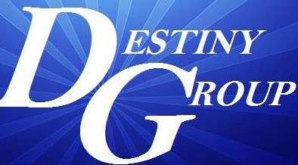

Hebrews 12:13 ¹And make straight paths for your feet, lest that which is lame be turned out of the way; but let it rather be healed.

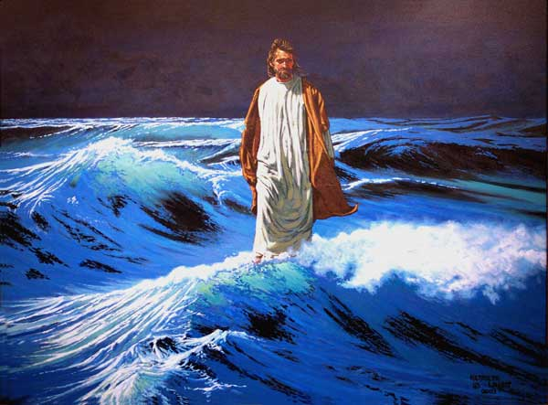
Jesus came walking on the
water!

John 6:16-24

Psalm 24:7 Lift up your heads, O ye gates; and be ye lift up, ye everlasting doors; and the King of glory shall come in.
This is a Transitional Shift

