Mentor School of Ministry

Dr Rick Kendall, Teacher

Descriptions of the workings & outcomes of this seminar class.

Interactive

Dialogue

Discovery

Researching

Revelation

Transition

Process

Potential

Activation

Change
Destiny Group Mentor School
296 SE St Lucie Blvd. Stuart, Florida 34996, Phone: 772-979-3409 E-mail: DrRickKendall@outlook.com
Course Series: Kingdom Economics and the Treasury of the New Jerusalem
Class #1: Introduction: The Storehouse, The Household & The New Jerusalem

- Revelation 21:10-11: And he carried me away in the spirit to a great and high mountain, and shewed me that great city, the holy Jerusalem, descending out of heaven from God, Having the glory of God: and her light was like unto a stone most precious, even like a jasper stone, clear as crystal;
Jasper symbolizes the glory of God; His splendor, brightness, magnificence and beauty. It symbolizes the blood atonement we have through the sacrifice of Jesus Christ. Jasper is compared to Pearl in one dimension: Polished/ Purified/ Perfected in LIGHT

Revelation 21:18-21 King James Version (KJV) And the building of the wall of it was of jasper: and the city was pure gold, like unto clear glass. And the foundations of the wall of the city were garnished with all manner of precious stones….(listed in verse) And the twelve gates were twelve pearls: every several gate was of one pearl: and the street of the city was pure gold, as it were transparent glass.

NOTE: The WALL (represents blueprint/ foundations), the GATES (represent governmental process), and the STREET (singular) (represents designation & destination fulfilled).

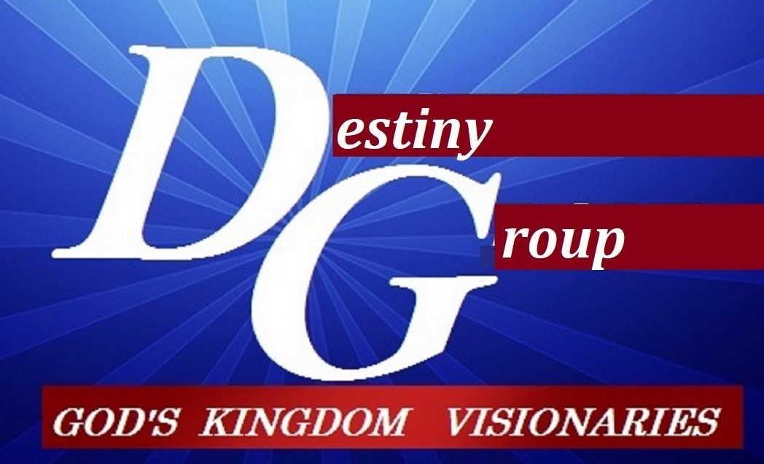

m

- The NEW Jerusalem (original blueprint of PEACE) the great City descends

  - Abraham: Looked for a CITY with foundation whose builder and maker is God (Heb.11:10)
  - Ephesians 2:19-22 ¹⁹Now therefore ye are no more strangers and foreigners, but fellow-citizens with the saints, and of the household (economy) of God; ²⁰And are built upon the foundation of the apostles (architects) and prophets (contractors), Jesus Christ himself being the chief corner stone (blueprint); In whom all the building fitly framed together groweth unto an holy temple in the LORD: In whom ye also are builded together for an habitation of God through the Spirit.

- Restoring the Economics begins with the HOUSEHOLD (Storehouse)

  - (Malachi 3:7) You have moved away from My ordinances (blueprint statutes)
  - Their question: “Wherein shall we return?” (how do we get back RIGHT?)
  - God answers with a question: “Will a man rob God?” “How have we robbed You?”
  - God’s answer: In tithes and offerings (taxes AND stewardship)
  - Why does God speak first to TITHE in response to returning to JUSTICE?
  - Because economic instability was the first transgression. The 1st Adam went in DEBT for one tree when he could’ve had all the other trees DEBT FREE.
  - This turned dominion to subjection, stewardship into ownership and blessing into debt cultivating a complex yoke of bondage.

- Bring the TITHES into the STOREHOUSE= depository, processing center, treasury

  - One of the Greek definitions of “order” is “taxes” & “tithes” (a tenth) but it not a DEBT (as modern day taxes), it’s an act of COVENANT and CITIZENSHIP
  - Malachi calls it the MEAT (or substance) and Offerings (to offer & promote)
  - Restoration of stewardship (possession) bringing access
  - Malachi 3:10 PROVE ME NOW and see if I will OPEN YOU to be my windows.
    - Pour you out a blessing that there is not room enough to contain it.
    - Rebuke the devourer and he shall not destroy the FRUIT of your ground
    - Vine shall not cast forth her fruit before the time.
    - All nations shall call you blessed.
  - NOTE: the ecology of process: Restoration of blueprint: impacting the economy of resources, ground, and dominion
Conclusion: The Nations shall call you BLESSED that operate from the STOREHOUSE that opens like a timed released VAULT full of ideas, innovations and wealth.

