Mentor School of Ministry

Dr Rick Kendall, Teacher

Descriptions of the workings & outcomes of this seminar class.

Interactive

Dialogue

Discovery

Researching

Revelation

Transition

Process

Potential

Activation

Change
Destiny Group Mentor School
296 SE St Lucie Blvd. Stuart, Florida 34996 Phone: 772-979-3409 E-mail: DrRickKendall@outlook.com
Course Series: Kingdom Economics and the Treasury of the New Jerusalem
Class #2: The Wealth IN the Mountain Transforming the Landscape

Last week we shared Revelation 21:10-11: And he carried me away in the spirit to a great and high mountain, and shewed me that great city, the holy Jerusalem, descending out of heaven from God, Having the glory of God: and her light was like unto a stone most precious, even like a jasper stone, clear as crystal.. the manifestation of the NEW Jerusalem

I.The MOUNTAIN is the FOUNDATION producing the CITY Blueprint & GEMS

- Micah 4:1: But in the last days it shall come to pass, that the mountain of the house of the LORD shall be established in the top of the mountains, and it shall be exalted above the hills; and people shall flow unto it.

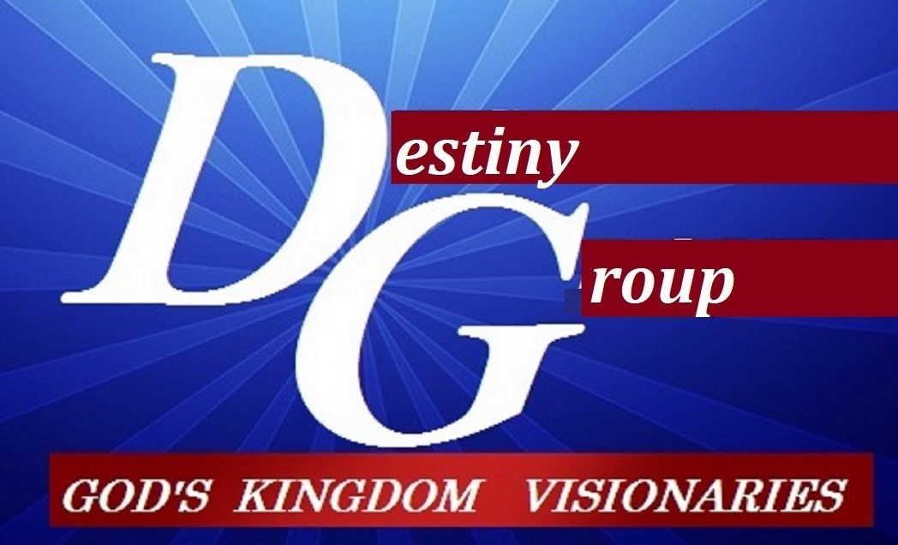

m

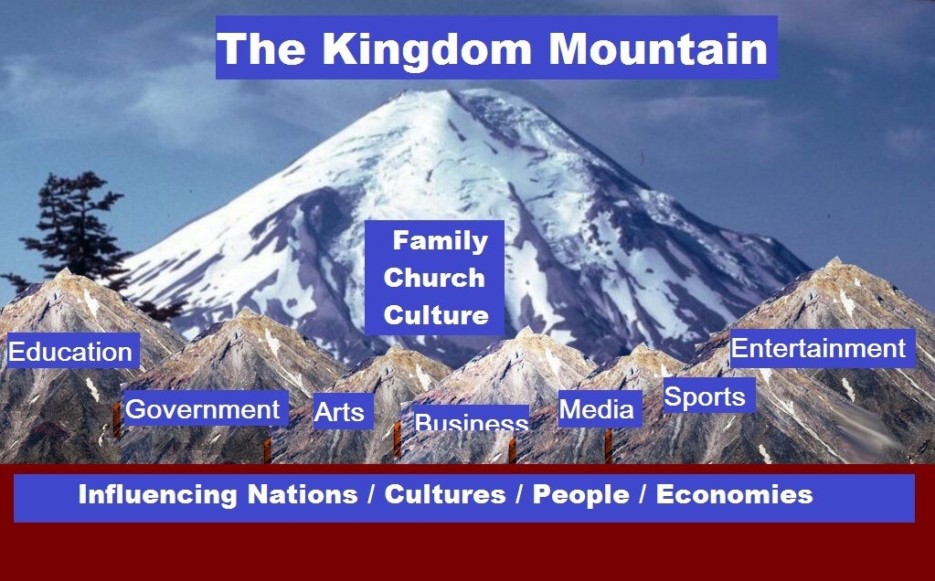
b. 1 Peter 2:5-9 (NIV) You also, like living stones, are being built into a spiritual house to be a holy priesthood, offering spiritual sacrifices acceptable to God through Jesus Christ. For in Scripture it says: "See, I lay a stone in Zion, a chosen and precious cornerstone, and the one who trusts in him will never be put to shame." Now to you who believe, this stone is precious. But to those who do not believe, "The stone the builders rejected has become the cornerstone," and, "A stone that causes people to stumble and a rock that makes them fall." They stumble because they disobey the message-which is also what they were destined for. But you are a chosen people, a royal priesthood, a holy nation, God's special possession, that you may declare the praises of him who called you out of darkness into his wonderful light.

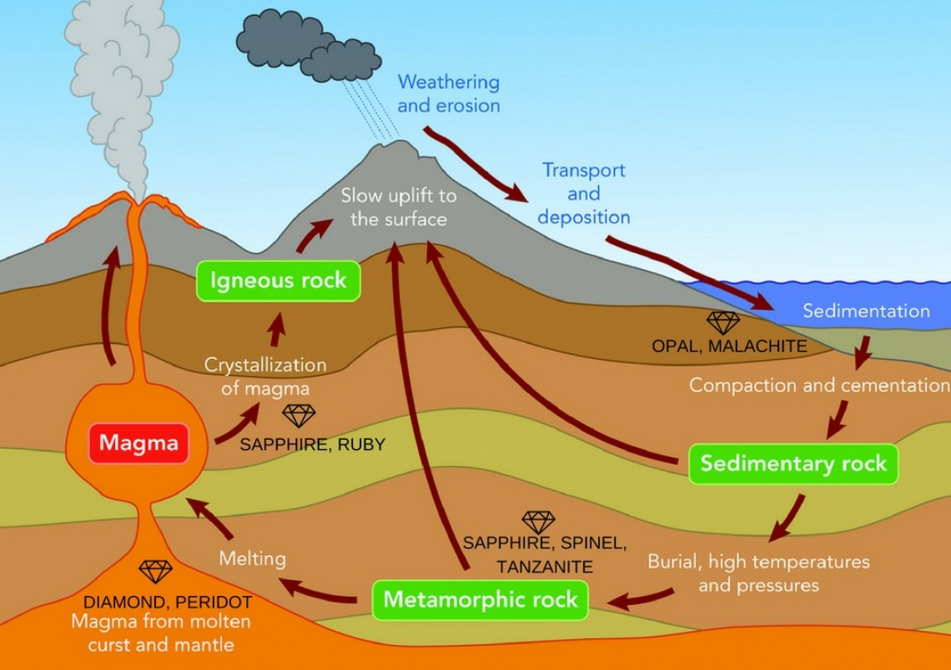
- There Are Hidden GEMS

a.The devil is not driving us out of God’s creation, but the devil is nervous because his time is short and God is driving him out!
b.Jewels begin as rock with ingredients.
c. As these GEMS manifest it shakes current corrupted systems.
d. We are not a religious molehill but a Kingdom Volcano

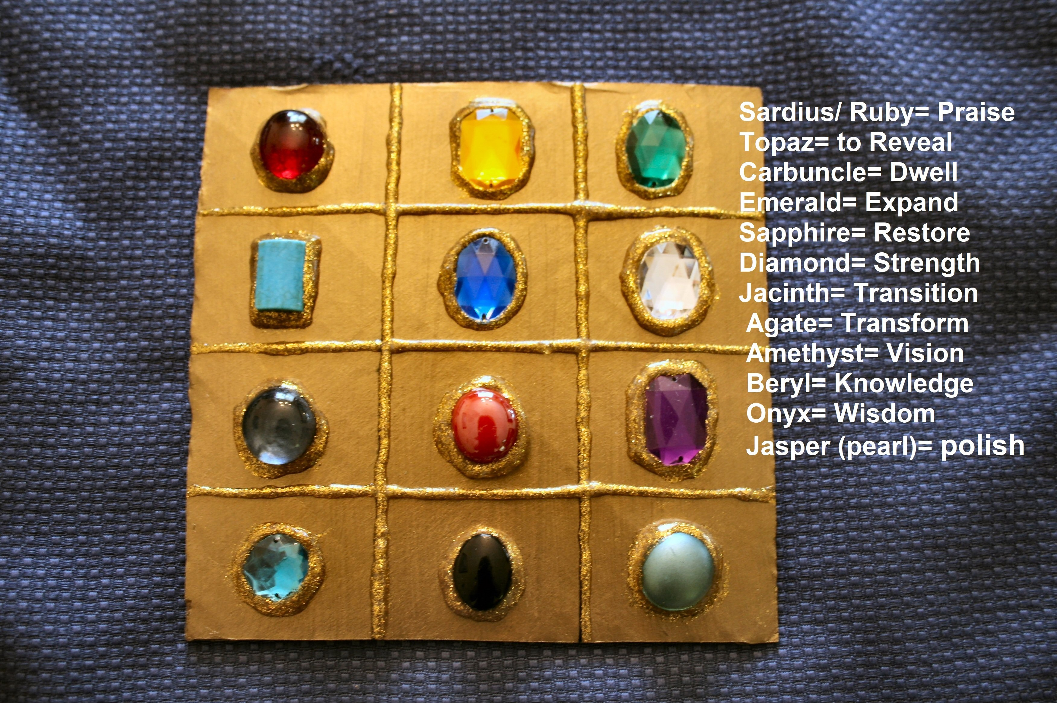

III. From the Ephod to the City Walls

- The Gems (Jewels) on the Breastplate of Aaron’s ephod represented the 12 tribes of Israel (depicting their place and progress). Ex. 28
- Gems represent: Strength/ Consistency/ Brillance/ Purity/ Light/ Royalty/ Character
- Revelation 21:19a, And the foundations of the wall of the city were garnished with all manner of precious STONES…(v.21) The 12 gates were 12 pearls.. and the street of the city was pure gold as it were transparent glass. This is the ECONOMIC VALUE in you!

