Mentor School of Ministry

Dr Rick Kendall, Teacher

Descriptions of the workings & outcomes of this seminar class.

Interactive

Dialogue

Discovery

Researching

Revelation

Transition

Process

Potential

Activation

Change
DESTINY GROUP MENTOR SCHOOL
296 SE St Lucie Blvd Apt. 202. Stuart, Florida 34996 Phone: 772-979-3409 E-mail: DrRickKendall@outlook.com
God’s Kingdom Economy & the Treasury of the New Jerusalem
Class #4: The Pearl, an Inside Job

Revelation 21:18-21 King James Version (KJV) And the building of the wall of it was of jasper: and the city was PURE GOLD, like unto clear glass. And the foundations of the wall of the city were garnished with all manner of precious stones… And the twelve gates were twelve pearls: every several gate was of one pearl: and the street of the city was PURE GOLD, as it were transparent glass.

NOTE: The WALL (represents blueprint/ foundations), the GATES (represent governmental process), and the STREET (singular) (represents designation & destination fulfilled).

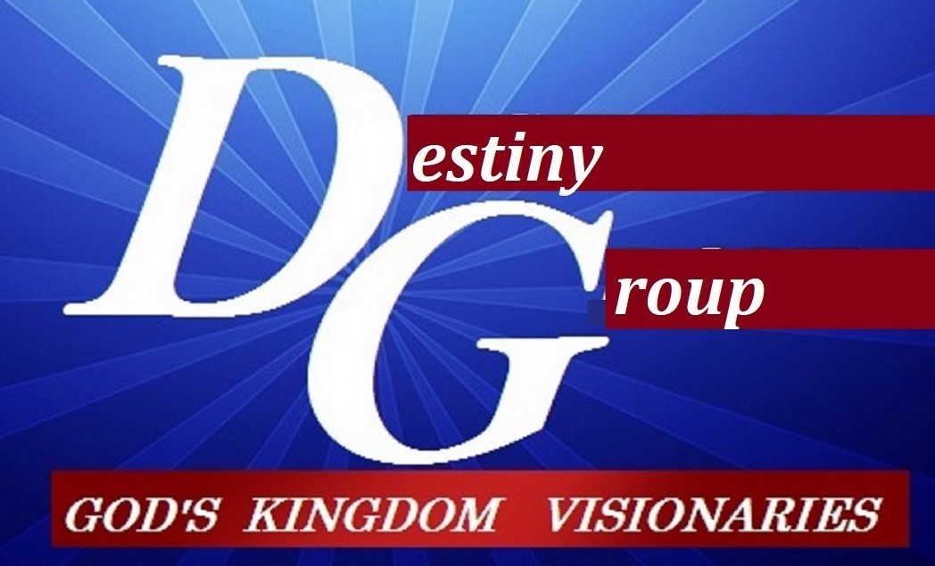

m
- Matthew 13 The kingdom of heaven is like…(something hidden in cultivation)

  - (v. 24) a unto a man who sowed good seed in his field (deposit)
  - (v. 31) a grain of mustard seed sown in a field (development)
  - (v. 33) a woman hiding leaven in meal (demand)
  - (v. 44-46) unto treasure hid in a field / a pearl of great price (defending)
  - (v. 47-52) a net filled with fish / a householder with treasure (defining)

- Note the PEARL of great PRICE (natural & rare) is unique from the other Gems

  - Stones=forming through pressure & fire of mineral into blueprint/ Pearls=eliminate and protect.
  - Pearls are formed when an irritant such as parasites, sand or food tries to come in.
  - To PROTECT itself, the Oyster secrets a mineral (aragonite) & protein (chochiolin)
  - This signifies the____________(mineral) & the_____________(protein)
  - This activity is purification cultivation: Beloved, now we are children of God, and it has not appeared as yet what we will be. We know that when He appears, we will be like Him, because we will see Him just as He is. And every man that hath this hope in him purifieth himself, even as he is pure. (IJohn 3:2,3)
  - NOTE: Gates of the City are Pearls, why?________________________________

- The Kingdom Economy is a RICH INWARD process that MANIFESTS outward WEALTH

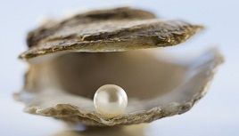

  - Treasure : _____________ = Inner RESERVES set for time release

  - Riches: ________________= Inner Strength from reserves: ERNEST

  - Wealth: ________________=Relationships, ideas, innovations, ready for transfer

  - Money: ________________= Currency (a current) drawn to assist in transfer of wealth for Kingdom assignments needed.

Notes:_______________________________________________________________________________________________________________________________________________________________________________________________________________________________________________________________________________________________________________________________________________________________________________________________________________________________________________________________________________

