Mentor School of Ministry

Dr Rick Kendall, Teacher

Descriptions of the workings & outcomes of this seminar class.

Interactive

Dialogue

Discovery

Researching

Revelation

Transition

Process

Potential

Activation

Change
DESTINY GROUP MENTOR SCHOOL
296 SE St Lucie Blvd Apt. 202. Stuart, Florida 34996 Phone: 772-979-3409 E-mail: DrRickKendall@outlook.com
God’s Kingdom Economy & the Treasury of the New Jerusalem
Class #5: The Process of Kingdom Economy & Reaction of Corrupt Systems

- Concerning the Kingdom economy principle of SEED, wheat & weeds, Jesus said: Matthew 13:38: The field is the world; the good seed are the children of the kingdom; but the tares are the children of the wicked one; (let them grow / process together until harvest).

- Man in a lost state got dependent on his systems of ownership/ debt/ & usury

- Recession: decline in economic trade / Inflation: decrease in purchasing power of money / Deflation: reduced supply of money & credit / Bankruptcy: inability to repay loans are not signs of the last days but results over time of ignoring God’s principle of letting the land rest & forgiveness of debts be realized.
Revelation 6:1-8 speaks of the 4 horsemen of the Apocalypse:
- It’s DEPENDENCY on these systems that Revelation 13:17 says: “so that they could not buy or sell unless they had the mark, (the name of the beast or number of its name.
- The SYSTEMS of this current world are ANTI-CHRIST (Anti-Kingdom Government & Economy) Revelation 6:1-8 speaks of the 4 horsemen of the Apocalypse:
- Conquest (by deception) /war (by dealings) /famine (by debt) /death (by dictatorship)
These are not names of the horses, it’s the (hidden spirit of the) RIDERS (“isms” or systems (on the back of process of unfolding) that drive them.
- What you depend on becomes your economy: For where your treasure is, there will your heart be also." (Luke 12:33, 34)

II. Matthew 12:29: To take a strong man’s house, first bind the strong man.

a. The SEED in the REAL ESTATE has authority to make a DEMAND on the GROUND to
ROOT OUT, CHANGE & EXPAND.
b. Isaiah 45:3, And I will give thee the treasures of darkness, and hidden riches of secret
places, that thou may know that I, the LORD, which call thee by thy name, am the God of Israel.

Where are these secret places?____________ Relational inheritance/ Character
- A Man / Woman of God (who I am) purpose
- A Mantle (weight I carry) power
- A Means (why I am/ Vision) perspective
- A Motivation (how I’m driven) passion
- A Movement (when I manifest) process
- A Measure (where I operate) progress
- A Mission (what I do) perform

NOTES ________________________________________________________________________________________________________________________________________________________________________________________________________________________________________________________________________________________________________________________________________________________________________________________________________________

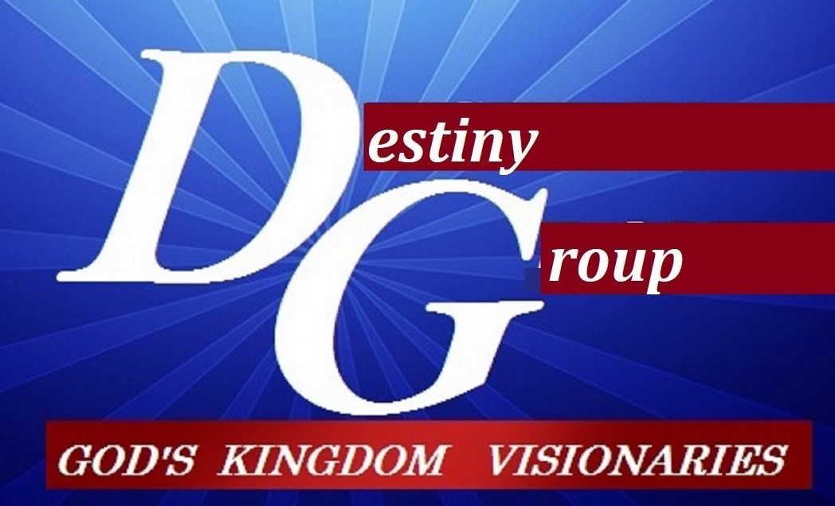

m

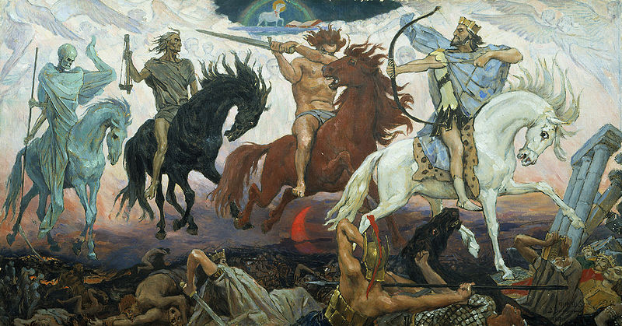
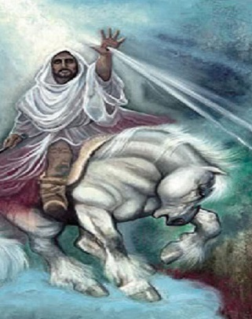
And I saw a white horse and He that sat on it called Faithful & True And in RIGHTEOUSNESS He judges & makes war. (Rev.19:11)

