Mentor School of Ministry

Dr Rick Kendall, Teacher

Descriptions of the workings & outcomes of this seminar class.

Interactive

Dialogue

Discovery

Researching

Revelation

Transition

Process

Potential

Activation

Change

DESTINY GROUP MENTOR SCHOOL
296 SE St Lucie Blvd Apt. 202. Stuart, Florida 34996 Phone: 772-979-3409 E-mail: DrRickKendall@outlook.com
God’s Kingdom Economy & the Treasury of the New Jerusalem
Class #7: The Principle of God’s Kingdom Commonwealth

Ephesians 2:12: That at that time ye were without Christ, being aliens from the commonwealth of Israel, and strangers from the covenants of promise, having no hope, and without God in the world:

We’ve been engrafted into a COMMONWEALTH that is uncommon in the world
It is not an “ism” or “religion” but an ETERNAL DOMINION
Israel: defined as “God rules/ God prevails” (chosen BASE of restoration of His government)

- Some definitions COMMONWEALTH does not start with COMMON money

  - Commonwealth: defined as “polity/ politeia” or community/ governance/ citizenship/ administration/ rights of citizens
  - Offshoot words from polity: polis/ police/ politics
  - Dictionary defines wealth as: much money, possessions, affluence (stuff)
  - Bible defines wealth as: a force, source, strength, creativity, & power.
  - World view of wealth (is outside in) Biblical view of wealth (is inside out)

- Common- wealth (in common with God) who owns it all= how we treat one another

  - What we consider our riches cultivates our wealth
  - Definition for “rich: the intake of possessions, abundance, and resources
  - Definition for “WEALTH” is TO GIVE, to TRANSFER, and RESOURCE
  - It’s not what we do that produces our wealth, but it is our wealth that produces what we do.
  - 1 Timothy 6:17 ¹⁷Charge them that are rich in this world, that they be not high-minded, nor trust in uncertain riches, but in the living God, who giveth us richly all things to enjoy.

III. As Ambassadors, we are called to be STEWARDS (Real Estate Agents)

  - Real (existing/ royal) Estate (Land, including resources in and on it, below it & above it. The buildings and permanent fixtures attached to it). Defining a beginning, the first place, principality, territory, rule)
  - To settle/ occupy/ establish new government and set jurisdiction
  - To take dominion and set principality
  - To set a realm/ sphere/ territory WITH THE INTENT TO TAKE GROUND!

GOD IS GOING TO GIVE YOU GROUND. GET READY!

NOTES ____________________________________________________________________________________________________________________________________________________________________________________________________________________________________________________________________________________________________________________________________________________________________________________________________________________________________________________________________________________________________________________________________________________________________________________________________________________________________________________________________________________________________________________________________________________________________________________________________________________________________________________________________________________________________________________________________________________________________________________________________________________________________________________________________________________________________________________________________

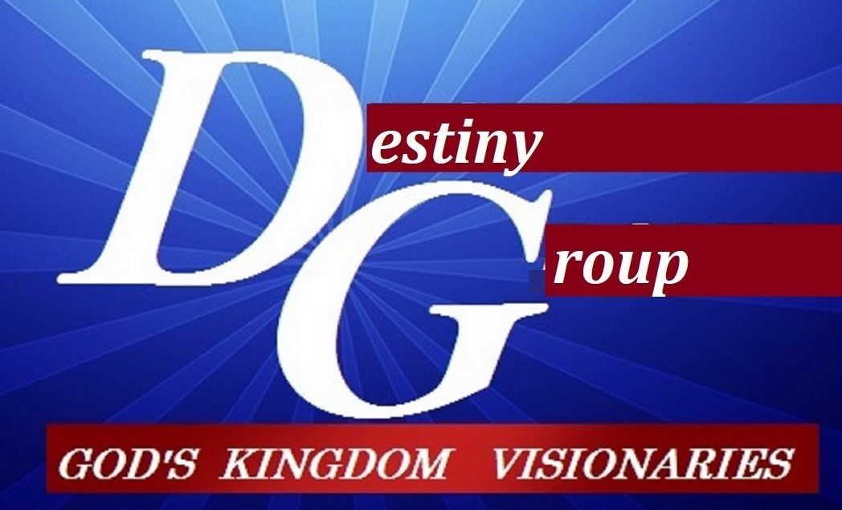

m

