Mentor School of Ministry

Dr Rick Kendall, Teacher

Descriptions of the workings & outcomes of this seminar class.

Interactive

Dialogue

Discovery

Researching

Revelation

Transition

Process

Potential

Activation

Change
DESTINY GROUP MENTOR SCHOOL
296 SE St Lucie Blvd Apt. 202. Stuart, Florida 34996 Phone: 772-979-3409 E-mail: DrRickKendall@outlook.com
God’s Kingdom Economy & the Treasury of the New Jerusalem
Final Test
NAME___________________________________ SCORE_______

Questions will be in the form of True or False/ Multiple Choice/ Fill In the Blank/ Match the Definition

- Fill in the Blank: The WALL (represents blueprint/ foundations), the GATES (represent governmental access & process), and the STREET (singular) represents __________________________________________

- True or False: Malachi 3:10 says; PROVE ME NOW and see if I will OPEN YOU to be my DOORS T___ F___

- Match the definition: Revelation 6:1-8 speaks of the 4 horsemen of the Apocalypse:
a. Conquest ___(by dictatorship).
b. War ___(by dealings)
c. Famine ___(by debt)
d. Death ___(by deception)

BONUS QUESTION: True or False: Conquest, War, Famine, & Death are the names of the horses, not the RIDERS on the back of them. T___ F___

- True or False: The foundations of the wall of the New Jerusalem fine GOLD representing us being processed. T___ F___

- Multiple Choice: CROWN =
a. royalty
b. authority
c. loyalty
d. All of the above
e. None of the above

- True or False: Pearls are formed when an irritant such as parasites, sand or food tries to come in to protect itself. T___ F___

- Fill in the Blanks: The Oyster secrets a mineral (aragonite) & protein (chochiolin) This signifies The________ (mineral) & the ______________(protein)

- Fill in the Blanks: What you depend on becomes your economy: For where your ________________is, there will your heart be also." (Luke 12:33, 34)

- Multiple Choice: Matthew 12:29: To take a strong man’s house, first bind the strong man and you have legal right to do this because,
a. HIS TITLE DEED EXPIRED
b. HE IS GREEDY
c. IT WAS NEVER HIS HOUSE, IT’S YOURS
d. NONE OF THE ABOVE

- True or False: The destiny of GROUND in the REAL ESTATE has authority to make a DEMAND on the SEED. T___ F___

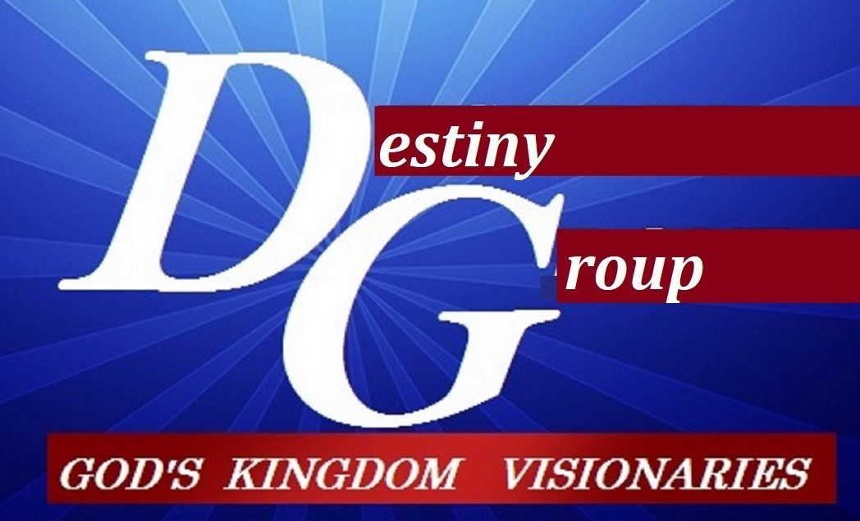

m

