Dr. Rick & Liz Kendall, Founder

Descriptions of the workings & outcomes of this seminar class.

Interactive

Dialogue

Discovery

Researching

Revelation

Transition

Process

Potential

Activation

Change

Welcome to the DESTINY GROUP MENTOR SCHOOL
Email: drrickkendall@outlook.com Phone: 772-979-3409
Course Series: Know How to Hear God, and How to Know Its God You Are Hearing
Final Test
Questions will be in the form of True or False/ Multiple Choice/ Fill in the Blanks & Match the Definition

NAME____________________________________________ Score______________

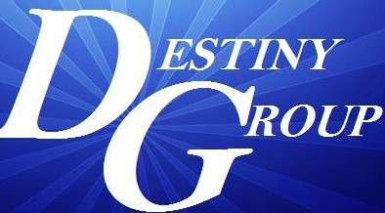

- Fill in the Blank: A genuine Prophetic Word will always _____________ to the principles of God’s Word. 2Tim.4:3,4

- True or False: The test of a genuine Prophetic Word is if it comes to pass. T__ F__

- Multiple Choice: 1Timothy 3:9 says we hold the mystery of the faith in
  - Manifestations
  - a. strong confession
  - a pure conscience

- Match the definition: NOTE the 5 main PRODUCTS of unknown tongue INTEL PROCESS are
    - Intimacy (worship) ___accountability (mind to understanding)
    - Revelation (who) ___accessibility (from spirit to mind)
    - Knowledge (what) ___applied (governing ourselves accordingly)
    - Prophesying (why) ___activated (discerning now from future view)
    - Doctrine (how) ___access (interaction and relationship)

- True or False: Praise: (Heb.) Zamar=Strike hands, Yadah=Sing songs, Halal=Shine forth T__ F__

- Fill in the Blank: Knowledge informs but Wisdom __________.

- Multiple Choice: To HEAR (is more than physical ear) but to
  - Receive, Perceive, Conceive
  - Be Knowledgeable, Available, Reliable
  - Presume, Assume, Resume

- True or False: Peace: to be perfectly joined together (convergence) aligned in God’s blueprint. T___ F___

- True or False: Our WALK becomes our PEACE (lifestyle/ direction/ progress). T__ F__

- Fill in the Blank: We ________________ on what God has already said to see & hear
what He’s saying!

