Dr. Rick & Liz Kendall, Founder

Descriptions of the workings & outcomes of this seminar class.

Interactive

Dialogue

Discovery

Researching

Revelation

Transition

Process

Potential

Activation

Change

Email: drrickkendall@outlook.com Phone: 772-979-3409
Dr. Rick Kendall D.D.
Florida State Christian College Class Edition
Impacting Our Sphere of Influence
Class 1: Introduction, Influence is the Result of Effective Outpouring

Acts 1:6 When they therefore were come together, they asked of him, saying, LORD, wilt thou at this time restore again the kingdom to Israel? Acts 1:7-8 And he said unto them, It is not for you to know the times or the seasons, which the Father hath put in his own power. But ye shall receive power, after that the Holy Ghost is come upon you: and ye shall be witnesses unto me both in Jerusalem, and in all Judaea, and in Samaria, and unto the uttermost part of the earth.
- Acts 2:6 Now when this was noised abroad, the multitude came together, and were confounded, because that every man heard them speak in his own language. Acts 2:17-18 And it shall come to pass in the last days, saith God, I will pour out of my Spirit upon all flesh: and your sons and your daughters shall prophesy, and your young men shall see visions, and your old men shall dream dreams: And on my servants and on my handmaidens I will pour out in those days of my Spirit; and they shall prophesy:
Precepts (birthing of thoughts) develop Concepts (ideas) that become our Perspective (viewpoints) Kingdom Culture Mindset is set, established, and activated from the prophetic future, but Earthly Cultural Mindset are set, established, and activated from the historical past.
SO OUR INFLUENCE IMPACTS DIMENSIONS & PARADIGMS!
  - Three basic points: to Impacting Our Appointed Spheres
    - It’s not about us or just for us, but is God moving through us to others (Acts 1:6)
    - Staying in our measure (metron) will create a ripple effect (Acts 1:7-8)
    - Our influence is prophetic/ and progressive generational vision (Acts 2:17-18)

  - We’ve been ORDAINED by God and given a PROPHETIC MEMORY
    - Jeremiah 1:5, 10 Before you were formed I knew you, & ordained you!
    - ANOINTED= constituted/ APPOINTED= consecrated/ ASSIGNED= confirmed/ ACTIVATED= commissioned
    - God’s Kingdom character is in us & it impacts a corrupted world.
    - Our PURPOSE: (gr: prothesis) or literally the "pro" to His "thesis"

  - We are colonizers and cultivators of a new dimensions in global spheres.

    - Our GIFT (abundance of purpose/ inner prosperity/ promise) makes room for us (Proverbs 18:16)
    - But it takes both Gift & Character to keep us in our position/ mantle/ place.
      - The GIFT is an operation but character is the administration
      - The GIFT is the manifestation but character is the mantle
      - The GIFT is an ability but character is the leadership
      - Can you identify your gift? Ephesians 4:11-12; He gave some, Apostles: sent to set, Prophets: see & say Evangelists: go & sow Pastors: seal & heal Teachers: know & grow
    - Our PURPOSE (who we are) sets our PLACES (what we do) revealing our PATHS (how to cultivate to it), manifesting His PROMISE & POWER
Next Week we will discuss impacting paradigms with the Keys of God’s Kingdom!

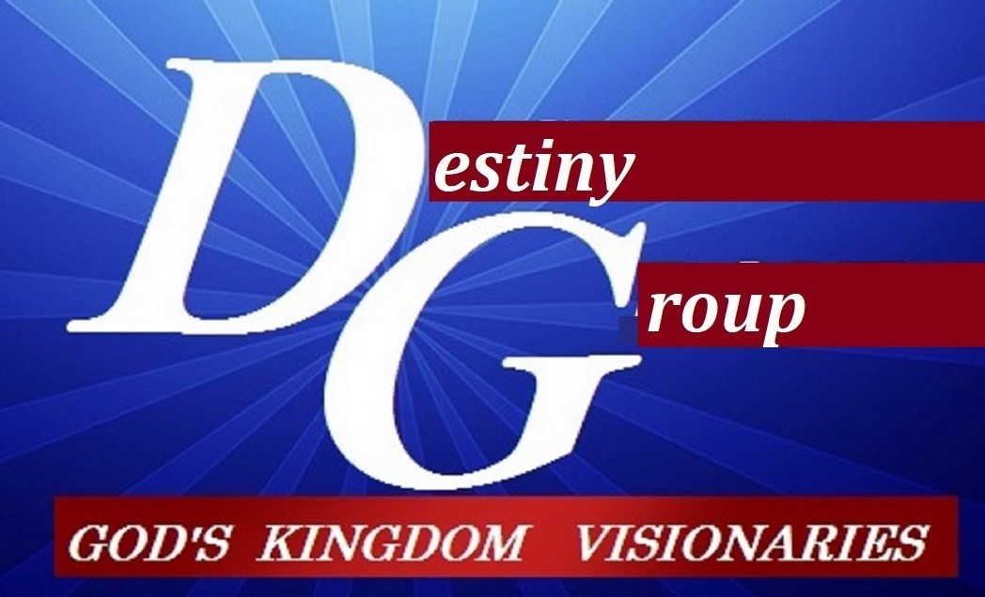

NOTES:_______________________________________________________________________________________________________________________________________________________________________________________________________________________________________________________________________________________________________________________________________________________________________________________________________________________________________________________________________________________________________________________________________________________________________________________________________________________________________________________________________________________________________________________________________________________________________________________________________________________________________________________________

