Dr. Rick & Liz Kendall, Founder

Descriptions of the workings & outcomes of this seminar class.

Interactive

Dialogue

Discovery

Researching

Revelation

Transition

Process

Potential

Activation

Change

Email: drrickkendall@outlook.com Phone: 772-979-3409
Dr. Rick Kendall D.D.
Florida State Christian University Class Edition
Impacting Our Sphere of Influence
Class 4: The Purpose & Protocol of Miracles, Signs & Wonders

Acts 2:22, Ye men of Israel, hear these words; Jesus of Nazareth, a man approved of God among you by miracles and wonders and signs, which God did by him in the midst of you, as ye yourselves also know: (miracles mentioned in Acts 6:8/ 8:6/ 8:13/15:12/19:11)
Matthew 24:24, For there shall arise false Christs, and false prophets, and shall shew great signs and wonders; insomuch that, if it were possible, they shall deceive the very elect. How can we know the difference? First we must know God’s purpose in them.

- There is a Distinction Between a Move of God & a Manifestation of God

- A move of God is underground producing a manifestation to be seen.
- 1 Corinthians 2:4 The Apostle Paul said: “And my speech and my preaching was not with enticing words of man's wisdom, but in demonstration of the Spirit and of power:” The DEMONSTRATION is the practical application shown for those learning how God will use them to do it not just in the church service, but to export it effectively.
- There are 2 Greek words for “miracle” dynamis:(power, might, strength) & sēmeion (unusual occurrence, transcending the common course of nature)
- NOTE: it’s from the inside out (there’s a miracle in you even NOW!

- Kingdom Culture impacts the world in 3 PROPHETIC dimensions…

- Miracles, Signs & Wonders are God’s original design impacting a corrupted world
  - Miracles: shifting environments (what)
  - Signs: significant change (why)
  - Wonders : shaking systems (how)

- The Spirit of God is the CONDUCTOR (the order of producing LIFE!)

  - The fruit of the Spirit (is about CULTIVATION & PRODUCING )… Gal.5:22,23 love, joy, peace, longsuffering, gentleness, goodness, faith, meekness, temperance. This is a revealed PROCESS of fruit (one singular fruit, not fruits)
  - The gifts of the Spirit flow through the fruit 1Cor.12:7-10
    - The Power to KNOW: Word of wisdom, Word of Knowledge
    - The Power to ACTIVATE: faith, gifts of healing, working of miracles.
    - The Power to SPEAK: prophecy, discerning of spirits, divers kinds of tongues, interpretation of tongues
  - All this is meant to impact the spheres of the world with Kingdom innovation!

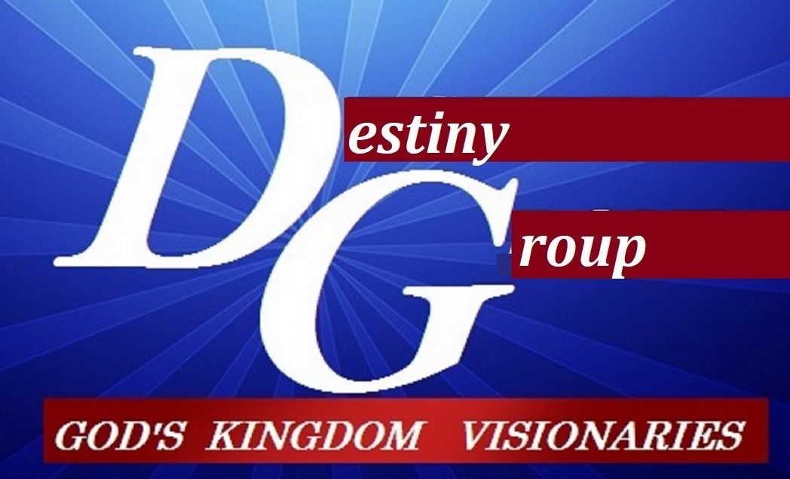

NOTES:_______________________________________________________________________________________________________________________________________________________________________________________________________________________________________________________________________________________________________________________________________________________________________________________________________________________________________________________________________________________________________________________________________________________________________________________________________________________________________________________________________________________________________________________________________________________________________________________________________________________________________________________________

