Dr. Rick & Liz Kendall, Founder

Descriptions of the workings & outcomes of this seminar class.

Interactive

Dialogue

Discovery

Researching

Revelation

Transition

Process

Potential

Activation

Change

Email: drrickkendall@outlook.com Phone: 772-979-3409
Dr. Rick Kendall D.D.
Florida State Christian University Class Edition
Impacting Our Sphere of Influence
Final Class Course Test
Name________________________________________________ Score___________

Answers will be in the form of True or False/ Fill in the Blanks/
Multiple Choice/ Match Definition

Each question will be worth 10 points
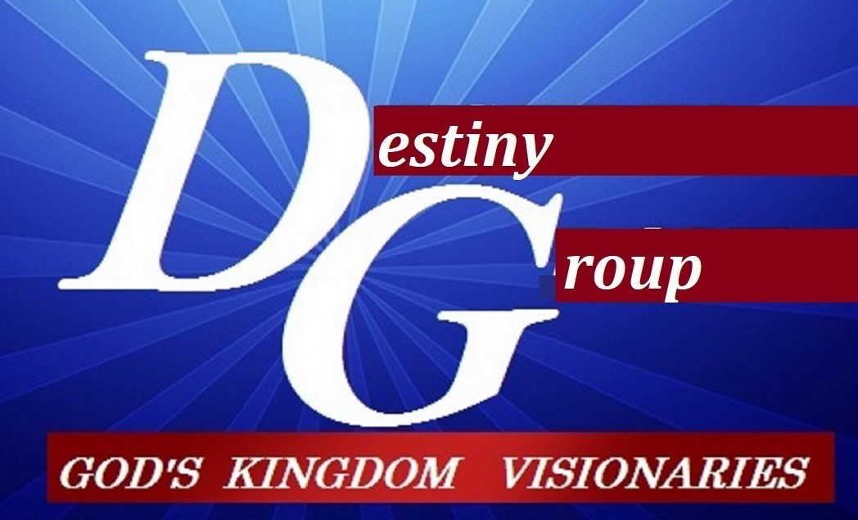

- True or False (choose one). Kingdom Culture Mindset is set, established, and activated from the historical past, but Earthly Cultural Mindset are set, established, and activated from the prophetic future. T___ F___

- Fill in the Blanks. Acts 2:17-18 And it shall come to pass in the last days, saith God, I will pour out of my Spirit upon all flesh: and your sons and your daughters shall prophesy, and your young men shall see ____________, and your old men shall ______________ dreams:

- Matche the Definitions.
  - Realms: _____rule (Matt.24:29)
  - borders : _____influence (2Cor.10:13)
  - spheres: _____ measure (Eph.3:18)
  - territories: _____government (Psalm 24:1)
  - through gates _____(outer governments)
  - doors _____(inner)

- Multiple Choice (choose one) Acts 4:17-32, The Sadducees commanded that Peter & John to…
  - stop doing miracles.
  - stop teaching in the Name of Jesus.
  - stop influencing the people.
  - none of the above.

- Fill in the Blank. In Acts 26 the Apostle Paul declared; Whereupon, O king Agrippa, I was not ____________________ unto the heavenly vision.

- True or False (choose one).The threshold= the entering point or beginning, to push beyond current comprehension, the threshing to eliminate the waste to proceed pure. T___ F___

- Multiple Choice (choose one). Colonization is: to establish a governmental culture in a foreign land. Which one of these definitions is not descriptive of colonization?
  - To settle/ occupy/ establish new government and set jurisdiction
  - To take dominion and set principality
  - To move the current occupants out of a territory
  - To set a realm/ sphere/ territory

- Fill in the Blank. Apostle Paul said: “And my speech and my preaching was not with enticing words of man's wisdom, but in __________________ of the Spirit and of power:”

- True or False (choose one).The fruit of the Spirit flow through the gifts. T___ F___

- Fill in the Blanks. Kingdom Culture impacts the world in 3 PROPHETIC dimensions… _______ (what) _______(why) _________ (how)

