Dr. Rick & Liz Kendall, Founder

Descriptions of the workings & outcomes of this seminar class.

Interactive

Dialogue

Discovery

Researching

Revelation

Transition

Process

Potential

Activation

Change

Email: drrickkendall@outlook.com Phone: 772-979-3409
Dr. Rick Kendall D.D.
Florida State Christian University Class Edition
Impacting Our Sphere of Influence
Class 4: The Purpose & Protocol of Miracles, Signs & Wonders
Study Sheet for Final Class Course Test

Answers will be in the form of True or False/ Fill in the Blanks/
Multiple Choice/ Match Definition

Each question will be worth 10 points
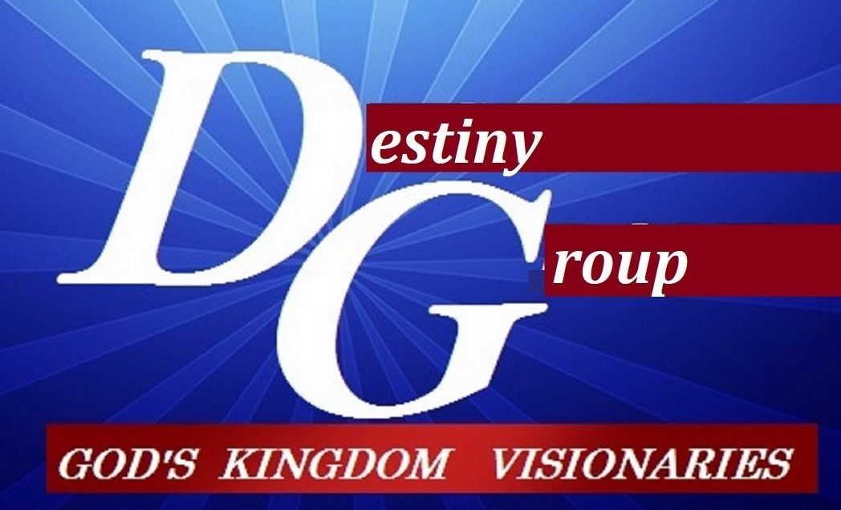

- Kingdom Culture Mindset is set, established, and activated from the prophetic future, but Earthly Cultural Mindset are set, established, and activated from the historical past.

- Acts 2:17-18 And it shall come to pass in the last days, saith God, I will pour out of my Spirit upon all flesh: and your sons and your daughters shall prophesy, and your young men shall see visions, and your old men shall dream dreams:

- Realms: rule (Matt.24:29) borders : measure (Eph.3:18) spheres: influence (2Cor.10:13)
territories: government (Psalm 24:1) through gates (outer governments) & doors (inner)

- Acts 4:17-32, The Sadducees commanded that Peter & John stop TEACHING in the NAME of JESUS!

- In Acts 26 the Apostle Paul declared; Whereupon, O king Agrippa, I was not disobedient unto the heavenly vision.

- The threshold= the entering point or beginning, to push beyond current comprehension, the threshing to eliminate the waste to proceed pure

- Colonization is: to establish a governmental culture in a foreign land.
  - To settle/ occupy/ establish new government and set jurisdiction
  - To take dominion and set principality
  - To set a realm/ sphere/ territory

- Apostle Paul said: “And my speech and my preaching was not with enticing words of man's wisdom, but in demonstration of the Spirit and of power:”

- The gifts of the Spirit flow through the fruit

- Kingdom Culture impacts the world in 3 PROPHETIC dimensions…
Miracles: (what) Signs: (why) Wonders: (how)

