M Mentor School of Ministry

Dr Rick Kendall, Teacher

Interactive

Dialogue

Discovery

Researching

Revelation

Transition

Process

Potential

Activation

Change
CLASS SYLABUS
296 SE St Lucie Blvd Apt 202 Stuart, Fl. 34996 Ph: 772-979-3409, E-mail: drrickkendall@outlook.com

COURSE: KINGDOM COME
Apostle Rick Kendall D.D.
CLASS 4: Kingdom Economics (the yoke is destroyed)
Ephesians 2:12, 19 ¹²That at that time ye were without Christ, being aliens from the commonwealth of Israel, and strangers from the covenants of promise, having no hope, and without God in the world:
¹⁹Now therefore ye are no more strangers and foreigners, but fellowcitizens with the saints, and of the household of God;
We’ve been engrafted into a COMMONWEALTH that is uncommon in the world
It is not an “ism” or “religion” but an ETERNAL DOMINION

- COMMONWEALTH does not start with money but inner process of treasure

  - Israel: (from Jacob to)He who rules / spiritual Israel in Christ Jesus, the first fruit (Vine) of chosen ground with Kingdom roots bringing commonwealth restoration.
  - Commonwealth: defined as “polity/ politeia” or governance/ citizenship/ conversation of lifestyle / administration / stewardship on behalf of the Owner/King
  - The world defines it as “isms”: money, possessions, ownership through debt.
  - The Kingdom defines as an process a GOVERNMENTAL process of Treasure (purpose) revealing Riches (strength) producing Wealth (wisdom) & resulting in Resources (supply) from the inside out

- COVENANTS of PROMISE: no longer strangers and foreigners

  - Ephesians 2:19-22: No longer strangers & foreigners, but FELLOWCITIZENS with the saints and the HOUSEHOLD of God (“oikonomia”) = ECONOMY, defined as ORDER of Government / management / stewardship / estate / dispensation
  - For the Kingdom to COME His WILL (covenant promise) must be DONE.
  - Every Kingdom MUST produce ECONOMIC STRENGTH that dismantles systems

- CULTIVATION: of this fitly framed House is SET on an unmovable FOUNDATION

  - Ephesians 2:20; ²⁰And are built upon the foundation of the apostles and prophets, Jesus Christ himself being the chief corner stone (of His Father’s government) SET on His shoulders with no end (us as Kingdom manifestations).
  - Isaiah 10:27 ²⁷And it shall come to pass in that day, that his burden (in context: the Assyrian) shall be taken away from off thy shoulder, and his yoke from off thy neck, and the yoke shall be destroyed because of the anointing (authorization)
  - This repositioned us to be the head & not the tail, from driven to driving.
  - Luke 9:62 And Jesus said unto him, No man, having put his hand to the plough, and looking back, is fit for the kingdom of God.
  - A plough cuts prophetically based on Covenants (absolutes) of PROMISE (declaration of PRO-PHETIC design God calls DONE)
  - Note: Isaiah 40: 3-5: A WAY was about to be ploughed in wilderness to become a HIGHWAY (or a thoroughfare, portal, or passage).
  - (v.4) valleys raised mountains lowered and crooked and rough places (out of order) made straight (back to the original blueprint
PART TWO of Kingdom Economics next week: The Storehouse & Real Estate

NOTES__NOTES:________________________________________________________________________________________________________________________________________________________________________________________________________________________________________________________________________________________________________________________________________________________________________________________________________________

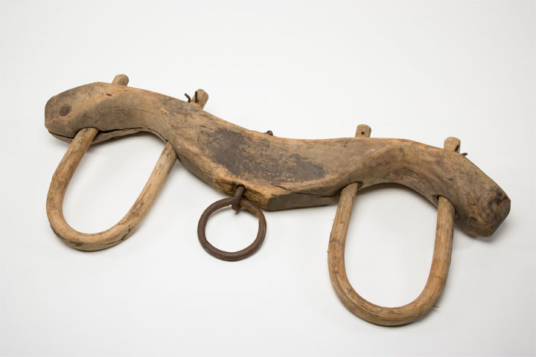

A system of debt is a result
of the fall from dominion
into subjection.
YOKE: to be directed
by what one is paired to & who
it is driven by.
The Beam: on the shoulders
represents GOVERNMENT/ RULE
The Brace: Around the neck
MINDSET/ PERCEPTION/ SUBJECTION
The Brass (ring): In the middle
DIRECTION/ PROCESS/ PERFORMANCE

