Mentor School of Ministry

Dr Rick Kendall, Teacher

Descriptions of the workings & outcomes of this seminar class.

Interactive

Dialogue

Discovery

Researching

Revelation

Transition

Process

Potential

Activation

Change

296 SE St Lucie Blvd. Stuart, Florida 34996 Phone: 772-979-3409 E-mail: DrRickKendall@outlook.com
Class Course: The Book of Revelation from God’s Kingdom Perspective

Study Sheet for Revelation Final Test

Questions will be in the form of True or False/ Multiple Choice/ Fill in the blanks/
& match the definition

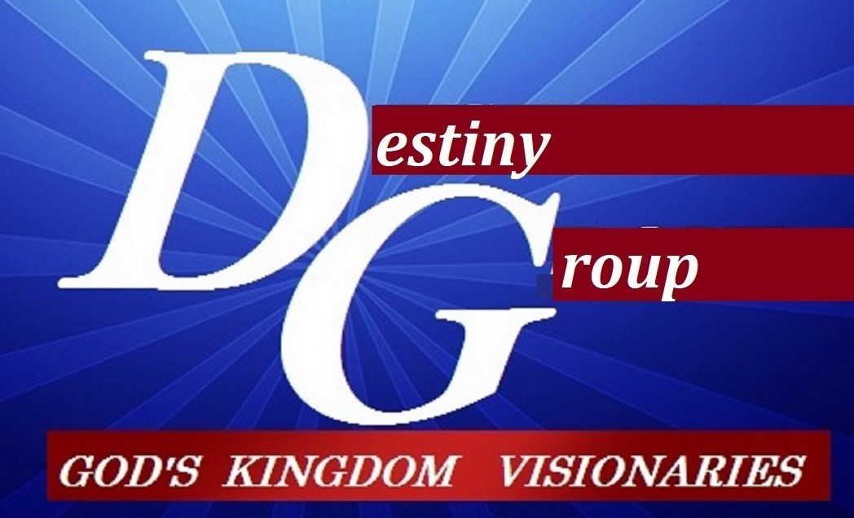

- This is a revelation of Jesus (not just events) to His Ambassadors.

- A door represents a threshold, passage, and a new level. The trumpet represents a shift and the release of going through / coming up

- The churches represented current conditions
  - Church at Ephesus (righteous but unmerciful)
  - Church at Smyrna, (longsuffering but resist fear)
  - Church at Pergamos (hospitable but compromising)
  - Church at Thyatira (giving but manipulating)
  - Church at Sardis (intercessors but sleepy)
  - Church at Philadelphia (Set an open door)
  - Church at Laodcea (you say you’re fine, but you are lukewarm)

- In the parable Matthew 22:4 (the Kingdom of heaven is like) the key words here; “all things are ready”

- The four horsemen of the apocalypse
a. White horse (conquest)
b. Red horse (war)
c. Black horse (famine)
d. Pale horse (death)

- You cannot read Revelation in a chronological timeline/ it’s an eternal snapshot

- Who is the sun clothes woman? Israel? The Church? Creation? YES!

- The Beast has 7 heads (leaders) 7 crowns (governments) & 10 horns (systems)

- The marriage of the Lamb is come (processed to full flourision) & His wife has made herself READY (complete) The Supper is not the Marriage

- The heavens OPENED and behold, a white horse, and He that sat on it was called Faithful and True and in righteousness he doth judge and make war. This is Jesus Christ.

NOTES:__________________________________________________________________________________________________________________________________________________________________________________________________________________________________________________________________________________________________________________________________________________________________________________________________________________________________________________________________________________________________________________________________________________________________________

