Mentor School of Ministry

Dr Rick Kendall, Teacher

Descriptions of the workings & outcomes of this seminar class.

Interactive

Dialogue

Discovery

Researching

Revelation

Transition

Process

Potential

Activation

Change

296 SE St Lucie Blvd. Stuart, Florida 34996 Phone: 772-979-3409 E-mail: DrRickKendall@outlook.com
Class Course: The Book of Revelation from God’s Kingdom Perspective
Week # 1: The Church Condition & Shifting Position
Things to remember about Revelations:
- It is not called the Book of Mysteries, but it’s the Revelation of Kingdom mysteries
- Revelation is the (Gr.) apokalypsis defined as laying bare, making naked, a full disclosure of truth, prophetic instruction, concerning divine things before unknown.
- The focus is not on events, but on why the events take place
- It is not an account of how God or we (as Kingdom citizens) are reacting to the devil, but how he is reacting to the entrance of God culminated Kingdom on earth.

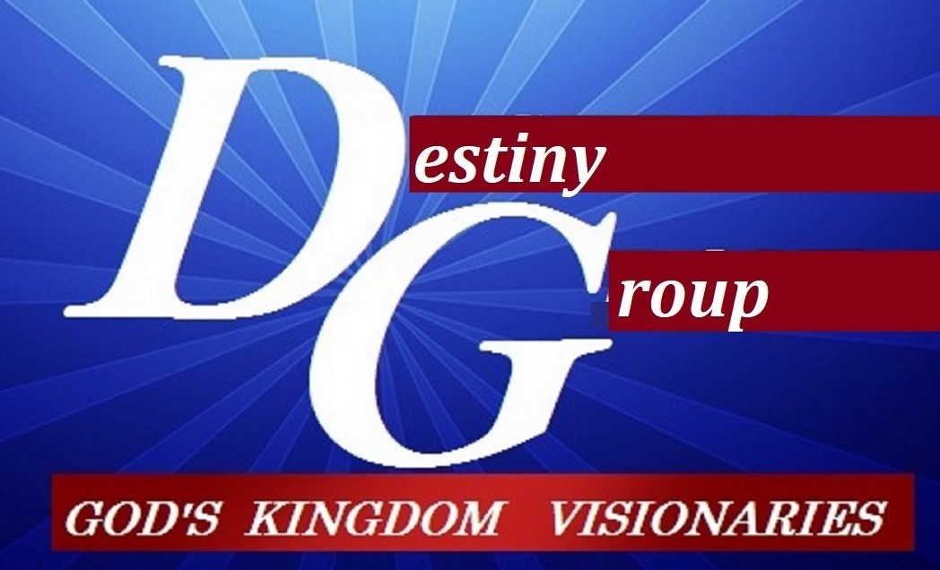

This 5 weeks is an overview from God’s Kingdom perspective.
Week #1 The Church Condition & Shifting Position
Week #2 Transition of Seals & Trumpets
Week #3 Judgement on Corrupt Systems
Week #4 Armageddon & Preparation
Week #5 New Jerusalem

- NOTE: This is a revelation of Jesus (not just events) to His Ambassadors
  - V. 3: Blessed is he/she that reads (knows the process of the Kingdom)
  - Blessed is he/she that hears (receives the purpose of the Kingdom)
  - Blessed is he/she that keeps (obeys the plan of the Kingdom)
  - Detail to 3 dimensions of the 7 churches (Rev. 1:4-6)
- Seven churches (Kingdom embassies),
- seven Spirits (representatives of the life of the Kingdom) positionally as
- kings and priests (through Jesus)
V. 10: and I heard behind me a great voice as of a trumpet (meaning transition/ shift/ new season) (v.11) I am Alpha and Omega, first & last.

- It’s preparation and processing time to a new level (paradigm) Rev. 2:1-3:22

  - Church at Ephesus (righteous but unmerciful, overcome= tree of life)
  - Church at Smyrna, (longsuffering but resist fear, overcome=crown of life)
  - Church at Pergamos (hospitable but compromising, overcome=hidden manna
  - Church at Thyatira (giving but manipulated , overcome=power over nations)
  - Church at Sardis (intercessors but sleepy, overcome=clothed in white)
  - Church at Philadelphia (Set an open door, overcome=pillars in the temple)
  - Church at Laodcea (you say you’re fine, but you are lukewarm, overcome to sit with him in His throne

- Chapter 4:1 A door was opened and another voice of a trumpet

  - A door represents a threshold, passage, and a new level
  - The trumpet represents the release of going through / coming up
  - (v.2-11) He saw the Throne, 24 elders (representing 12 tribes/ 12 apostles), 7 lamps representing the 7 aspects of the Spirit, seas of glass, 4 beasts (Lion=proclaimation, Calf=provision, Man=process, Eagle=progress)

NOTES:_________________________________________________________________________________________________________________________________________________________________________________________________________________________________________________________________________________________________________________________________________________________________________________________________________________________________________________________________________________________________________________________________________________________________________________________________________________________________________________________________________________________________________________________________________________________________________________________________________________________________________________________________________________________________________________

