Mentor School of Ministry

Dr Rick Kendall, Teacher

Descriptions of the workings & outcomes of this seminar class.

Interactive

Dialogue

Discovery

Researching

Revelation

Transition

Process

Potential

Activation

Change

296 SE St Lucie Blvd. Stuart, Florida 34996 Phone: 772-979-3409 E-mail: DrRickKendall@outlook.com
Class Course: The Book of Revelation from God’s Kingdom Perspective
Week # 2: Seals & Trumpets
Things to remember about Revelations:
Remember from last week: It is not called the Book of Mysteries, but it’s the Revelation of Kingdom mysteries. The focus is not on events, but on why the events take place. It is not an account of how God or we (as Kingdom citizens) are reacting to the devil, but how he is reacting to the entrance of God culminated Kingdom on earth.

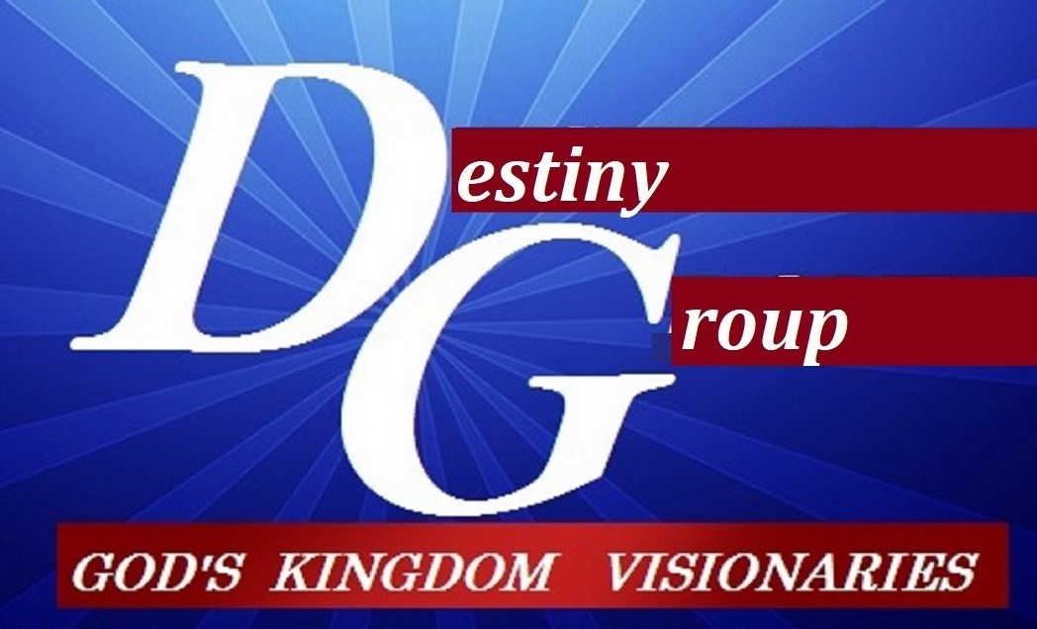

2 Peter 3:10-13 The elements shall melt with a fervent heat so take heed what manner of persons you ought to be in all holy conversation and godliness The elements are literally: something set in order or steps, fundamental principles and Conversation is literally: citizenship lifestyle

- A Trumpet/ Voice (time shift) new level… (Rev.chap. 5-chap.11)

  - Seven seals (opened by Jesus) mysteries released, destroying corrupt systems
  - Chap. 7 (parenthetical) 144,000 (12,000) of each tribe sealed & then multitude of saints
  - Seven trumpets (7 angels) principalities, the heavens & earth begins renovation.
  - Note: the numbers 12 & 7 are significant throughout Revelation
12 = government, 7 = complete
  - Where are we? The “rapture” (biblically caught up) is not escape but transition.
  - Not an event, but a process that culminates. We are the orchestra, not the audience

7 seals sifting world systems
- White horse (conquest)
- Red horse (war)
- Black horse (famine)
- Pale horse (death)
- Martyrs
- Introduction to Sifting
- Silence & IntroTrumpets

- Revelation 11:15, And the seventh angel sounded; and there were great voices in heaven, saying, The kingdoms of this world are become the kingdoms of our LORD, and of his Christ; and he shall reign for ever and ever. NOTE: this will make the beast react

NOTES:_______________________________________________________________________________________________________________________________________________________________________________________________________________________________________________________________________________________________________________________________________________________________________________________________________________________________________________________________________________________________________________________________________________________________________________________________________________________________________________________________________________________________________________________________________________________________________________________________________________________________________________________________________________________________________________________________________________________________________________________________________________________________________________________________________________________________________________________________________________________________________________________________________________________________________________________________________________________________________________________________________________________________________________________________

7 Trumpets shifting creation & judging corruption
1. Fire
2. Blood
3. Sea poisoned
4. Sun/ moon/ stars 3rd darkened
5. Plagues
6. Fallen angels released as consequeces
7. Earthquakes (shift)

