Mentor School of Ministry

Dr Rick Kendall, Teacher

Descriptions of the workings & outcomes of this seminar class.

Interactive

Dialogue

Discovery

Researching

Revelation

Transition

Process

Potential

Activation

Change

296 SE St Lucie Blvd. Stuart, Florida 34996 Phone: 772-979-3409 E-mail: DrRickKendall@outlook.com
Class Course: The Book of Revelation from God’s Kingdom Perspective
Week # 4: Marriage Supper of the Lamb

Matthew 22:4, Again, he sent forth other servants, saying, Tell them which are bidden, Behold, I have prepared my dinner: my oxen and my fatlings are killed, and all things are ready: come unto the marriage.
In this parable (the Kingdom of heaven is like) the key words here; “all things are ready”
The initial marriage covenant has already taken place, this is the supper.

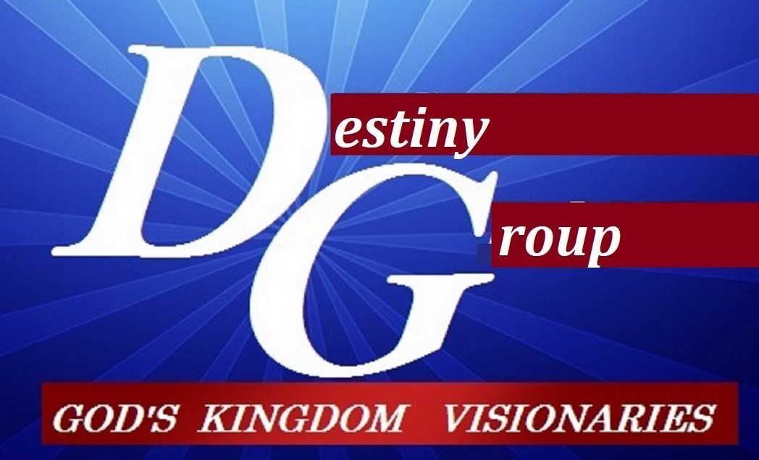

Supper = culmination wrap up to start a new beginning.

- Babylon in league with the beast falls: Revelation chapter 17-18

  - Mystery Babylon defined as committing fornication (compromise) with systems
  - Religions of men joining in with world systems is an adulterous mixture.
  - Nimrod was king of Babylon. The name Nimrod comes from the Hebrew verb marad, meaning “rebel” a representative, of a system that is epitomized in rebellion against the Creator, the one true God. The essence of philosophy: We rise up, you come down.
  - This culminates in Babylon being burned and brought down.

- The Marriage Supper of the Lamb: Revelation 19:1-10

  - The marriage of the Lamb is come (processed to full flourision) & His wife has made herself READY (complete) Rev. 19:7
  - (v.10) for the testimony of Jesus IS the spirit of PROPHECY.
  - This culmination represents a major SHIFT into Chapter 19:11-16
  - The heavens OPENED and behold, a white horse, and He that sat on it was called Faithful and True and in righteousness he doth judge and make war
1. eyes flame of fire
2. on His head many crowns
3. clothed in a vesture dipped in blood
4. His Name is called The Word of God
5. His armies followed Him on white horses in clean linen (great wedding reception)
6. Out of His mouth a sharp sword to rule the nations
7. The vesture on His thigh is a Name written, King of Kings & Lord of Lords

- The battle of Armageddon: great cleansing (referred Rev. 16:16) defined in Rev. 19:19-21

  - It’s referred to as the “great supper (culmination) of God (His judging a thing)”
  - Revelation 20: 1-10 The devil is bound 1000 years while positions are assumed
  - Then he’s released to try to deceive one more time (sifting those who could be corrupted)
  - The devil is cast into the lake (body) of fire (continual refining pur-ifacation)
  - The great white throne judgement / books & book of life opened

NOTES:_______________________________________________________________________________________________________________________________________________________________________________________________________________________________________________________________________________________________________________________________________________________________________________________________________________________________________________________________________________________________________________________________________________________________________________________________________________________________________________________________________________________________________________________________________________________________________________________________________________________________________________________________________________________________________________________________________________________________________________________________________________________________________________________________________________________________________________________________________________________________________________________________________________________________________________________________________________________________________________________________________________________________________________________________

