Mentor School of Ministry

Dr Rick Kendall, Teacher

Descriptions of the workings & outcomes of this seminar class.

Interactive

Dialogue

Discovery

Researching

Revelation

Transition

Process

Potential

Activation

Change

296 SE St Lucie Blvd. Stuart, Florida 34996 Phone: 772-979-3409 E-mail: DrRickKendall@outlook.com
Class Course: The Book of Revelation from God’s Kingdom Perspective
Week # 5: The New Jerusalem
- Revelation 21:1, And I saw a NEW heaven and a NEW earth: for the first heaven and the first earth were passed away; and there was no more sea.
- The word NEW is not as though it just happened, but reconciled to the original blueprint.
- The first here is not “beginning” but (Gr. Protos) former prototype the got corrupted.
- The “sea” here is the philosophies & restlessness of mankind producing beasts rising out of it

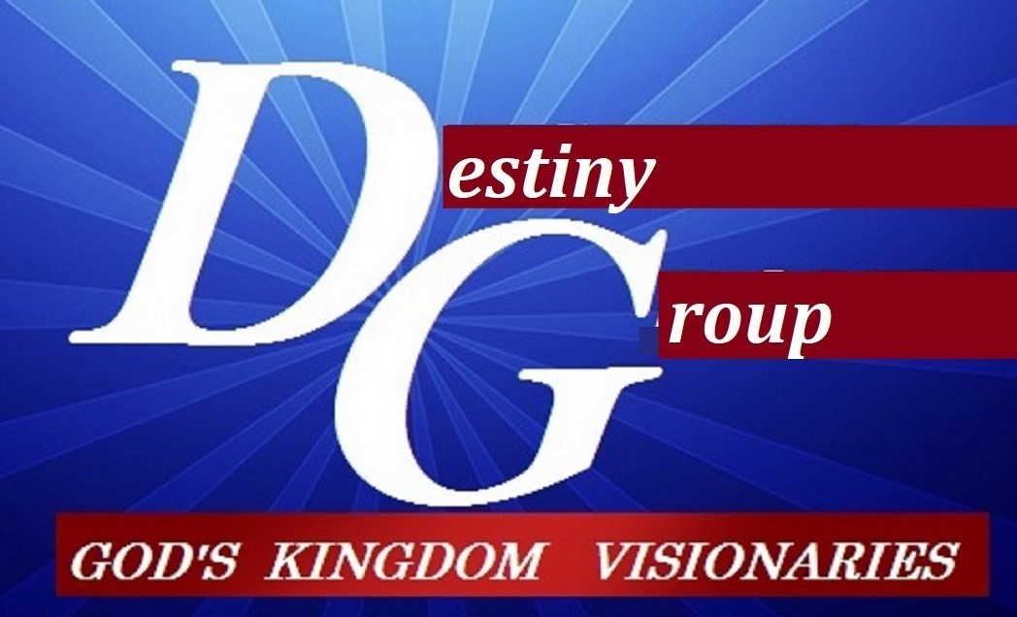

2Peter 3:10, But the day of the Lord will come as a thief in the night; in the which the heavens shall pass away with a great noise, and the elements shall melt with fervent heat, the earth also and the works that are therein shall be burned up (not burned out). Renovation not termination

- The vision of the New Jerusalem prepared as a bride adorned for her husband (Rev.21:2)

  - NEW (original) Jerusalem city of eternal peace on earth as it is in heaven.
  - The Holy City (Kingdom realm & rule)
  - The bride is the glorious church? (Eph.5:27) Is it NEW heaven & earth? (John 3:16)___

- The description of the NEW Jerusalem descending (culminated reconnecting)

  - Rev. 21:11 The glory of God & her light like clear Jasper
  - Revelation 21:18-21 King James Version (KJV) And the building of the wall of it was of jasper: and the city was pure gold, like unto clear glass. And the foundations of the wall of the city were garnished with all manner of precious stones, and the twelve gates were twelve pearls: every several gate was of one pearl: and the street of the city was pure gold, as it were transparent glass.
  - NOTE: The WALL (represents blueprint/ apostolic foundations), the GATES (represent governmental process), and the STREET (singular) (represents designation & destination fulfilled).
  - 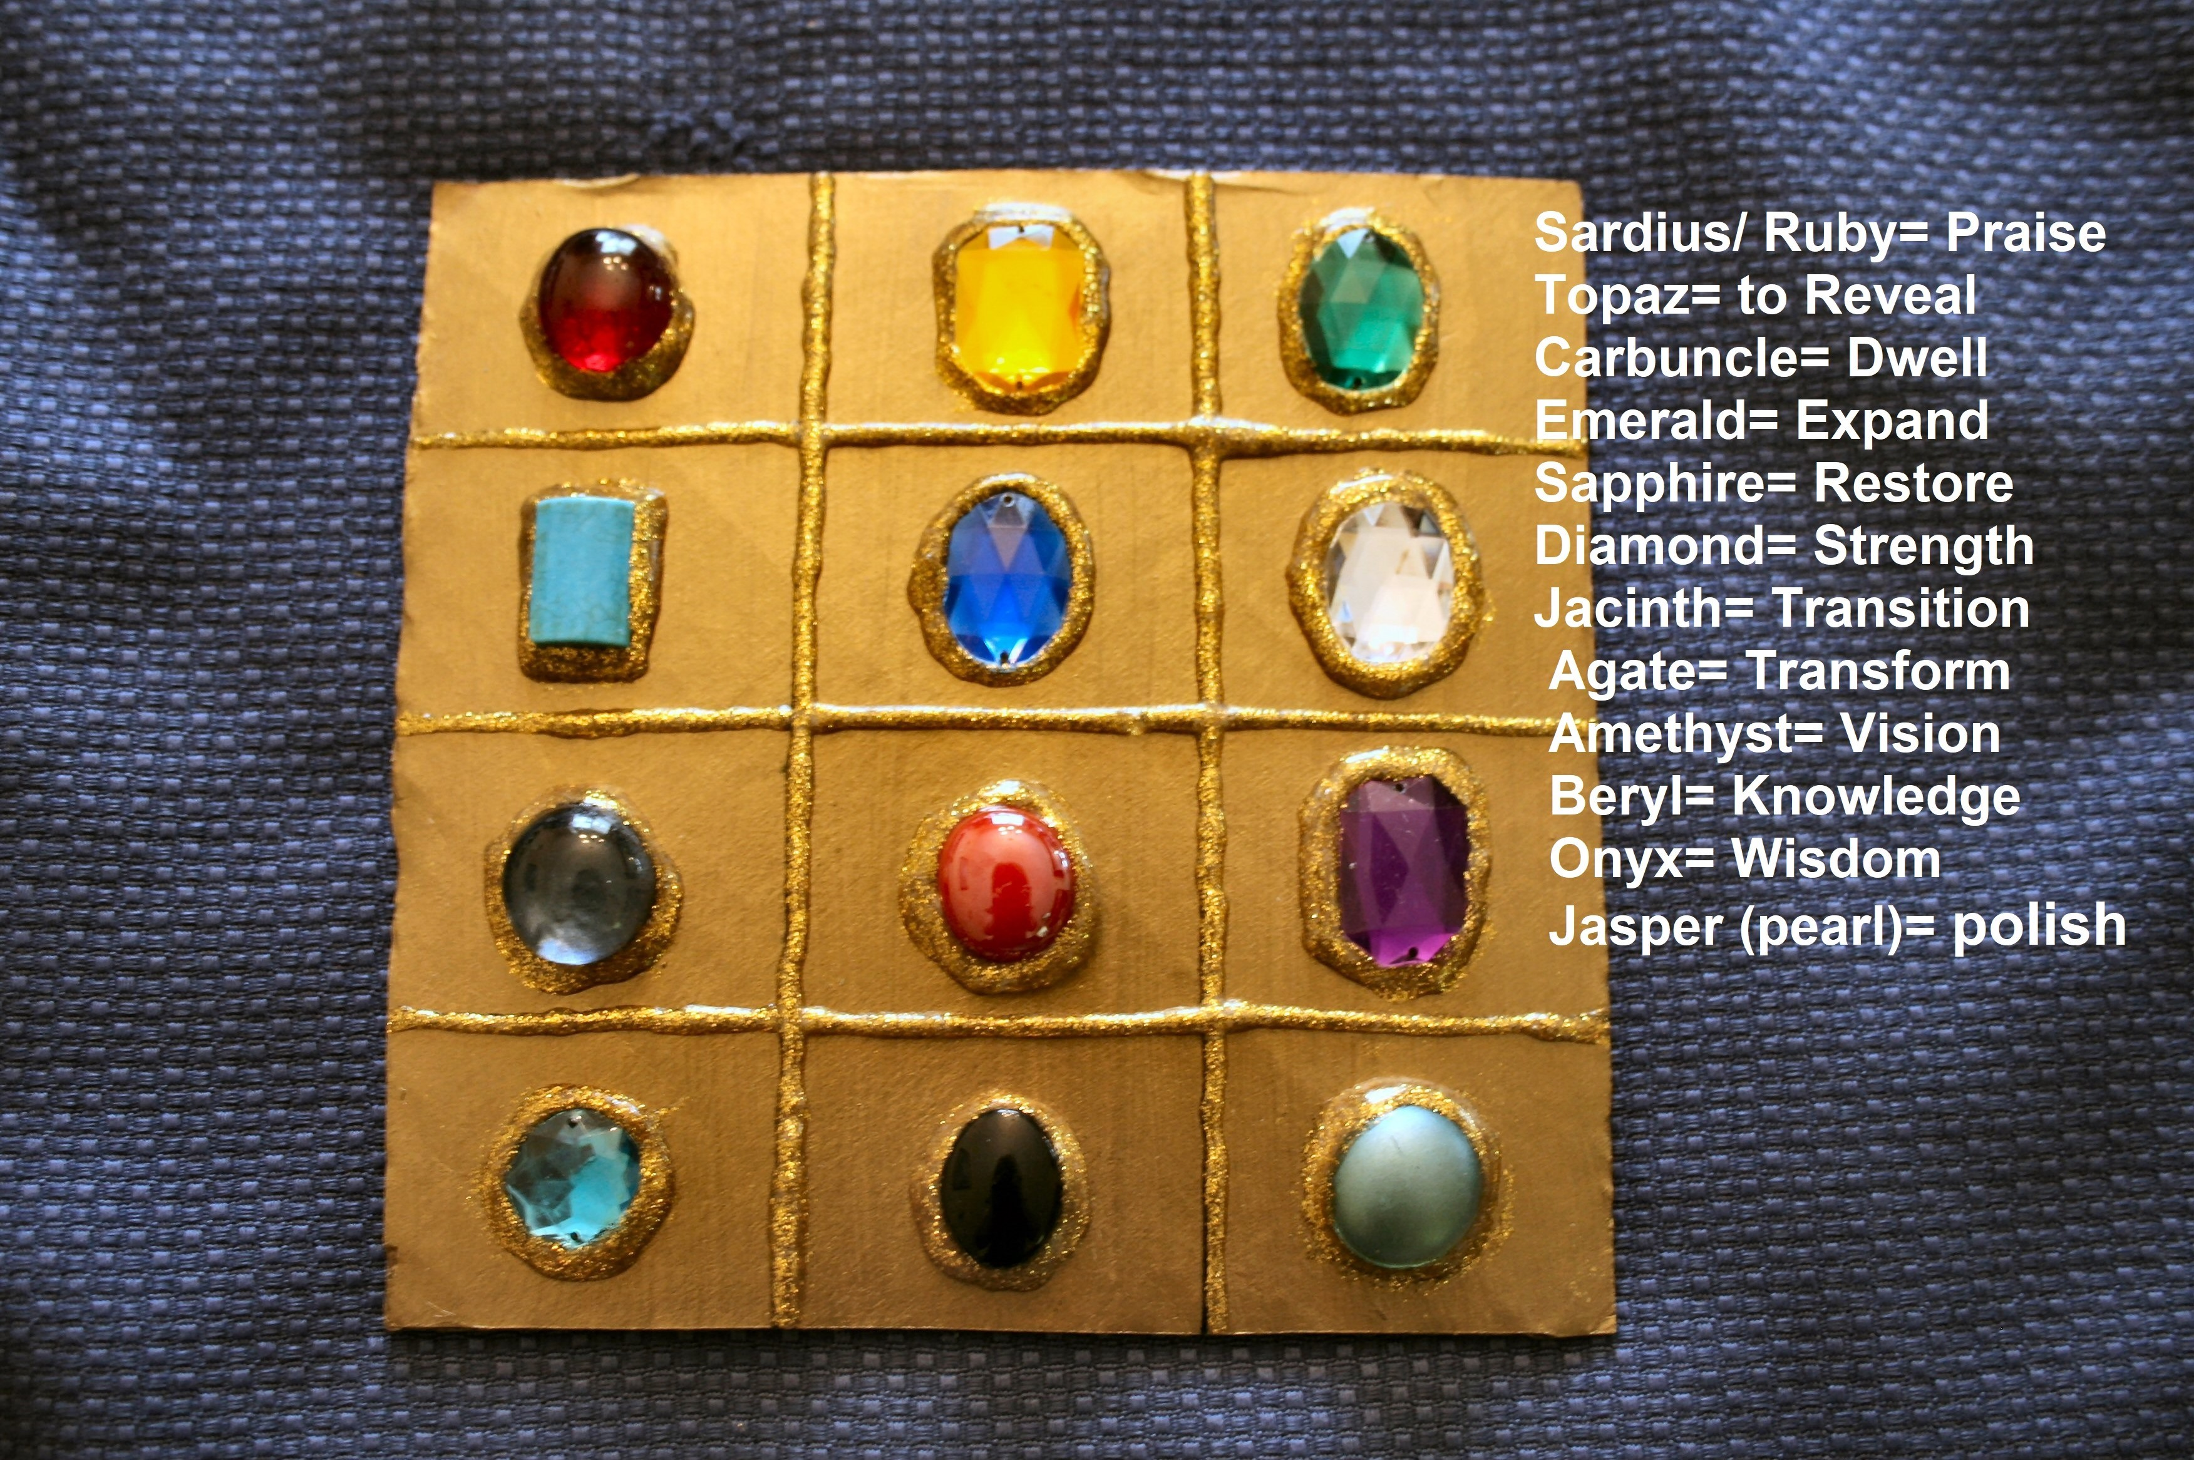 The process, Kingdom gems.

- The Water, the Tree of Life, Fruit & the Leaves (Rev. 22:1 & 2)

  - Pure river proceeding out of the throne & the Lamb
  - The tree of Life bearing 12 manner of fruits & leaves for the healing of nations
  - Rev. 22:13, 14, I am Alpha and Omega, the beginning and the end, the first and the last. Blessed are they that do his commandments, that they may have right to the tree of life, and may enter in through the gates into the city.
  - Revelation 22:17-19, And the Spirit and the bride say, Come. And let him that heareth say, Come. And let him that is athirst come. And whosoever will, let him take the water of life freely.
NOTES:_______________________________________________________________________________________________________________________________________________________________________________________________________________________________________________________________________________________________________________________________________________________________________________________________________________________________________________________________________________________________________________________________________________________________________________________________________________________________________________________________________________________________________________________________________________________________________________________________________________________________________________________________________________________________________________________________________________________________________________________________________________________________________________________________________________________________________________________________________________________________________________________________________________________________________________________________________________________________________________________________________________________________________________________________

