
Mentor School of Ministry

Dr Rick Kendall, Teacher

Descriptions of the workings & outcomes of this seminar class.

Interactive

Dialogue

Discovery

Researching

Revelation

Transition

Process

Potential

Activation

Change

Jesus is Lord!

296 SE St Lucie Blvd. Apt. 202, Stuart, Fl. 34996 Phone: 772-979-3409
E-mail: drrickkendall@outlook.com

Course: Majesty: The Authority & Power Of The King
Class #2: The Crown & The Sceptre of the Kingdom

Isaiah 62:2-3, ²And the Gentiles shall see thy righteousness, and all kings thy glory: and thou shalt be called by a new name, which the mouth of the LORD shall name. ³Thou shalt also be a crown of glory in the hand of the LORD, and a royal diadem in the hand of thy God.
MAJESTY: Heb. Howd, Soverereign Authority/ in the Highest/ manifesting His glory/ the Excellency that produces His Splendor/ Beauty and Dominion

CROWN: Heb. Nezer; consecration/ separation, Gr. stephanos: a mark of royal or exalted rank
Defined by the world as crowning achievements but in the Kingdom of God is a crown already set by Name but in development by activation.

- SET: God is cultivating our CROWN by how we grow into His Image (character)

    - The CROWN and DIADEM (encircling application)-(literally a MINDSET of the HEART) are in the HAND of the King (Isaiah 62:3)
    - 1 Corinthians 2:16 ¹⁶For who hath known the mind of the LORD, that he may instruct him? but we have the mind of Christ.
    - Crown= designated mark of honor, position, not an AWARD for doing but a developing REWARD of being in His process of purpose.
    - 1 Corinthians 9:25 ²⁵And every man that striveth for the mastery is temperate in all things. Now they do it to obtain a corruptible crown; but we an incorruptible.

- STONED: The Crown reveals the Treasure once Hidden Now Manifested

    - Zechariah 9:16 ¹⁶And the LORD their God shall save them in that day as the flock of his people: for they shall be as the stones of a crown, lifted up as an ensign upon his land.
    - Not only do we wear crowns, but we are crowns of His glory.
    - Our life processes & reveals treasure through His Crown as royalty. 2 Corinthians 4:7, But we have this treasure in earthen vessels, that the excellency of the power may be of God, and not of us.
    - The Imperial State Crown of the King or Queen of England weighs 2 lbs 13 oz. It is framed in gold and silver having 2,873 diamonds, 273 pearls, 17 sapphires, 11 emeralds, 5 rubies including one huge ruby & one huge sapphire.
    - We as Kingdom Citizens are in process of Crown of righteousness (2Tim.4:8), Crown of glory (1Peter 5:4), Crown of life (James 1:12) tried in the Fire and refined by the Holy Spirit!
- SCEPTRED: Activation of Kingdom Authority and Power in & Through Us

- Hebrews 1:8, But unto the Son he saith, Thy throne, O God, is for ever and ever: a sceptre of righteousness is the sceptre of thy kingdom.
- SCEPTRE: Heb. Shebet: rod, staff, mark of authority, a spear Gr. rhabdos: royal branch, offshoot, tribe, royal nation
- In every scepter is the image of the crown it represents.
- Numbers 17:8 ⁸And it came to pass, that on the morrow Moses went into the tabernacle of witness; and, behold, the rod (scepter) of Aaron for the house of Levi was budded, and brought forth buds, and bloomed blossoms, and yielded almonds.

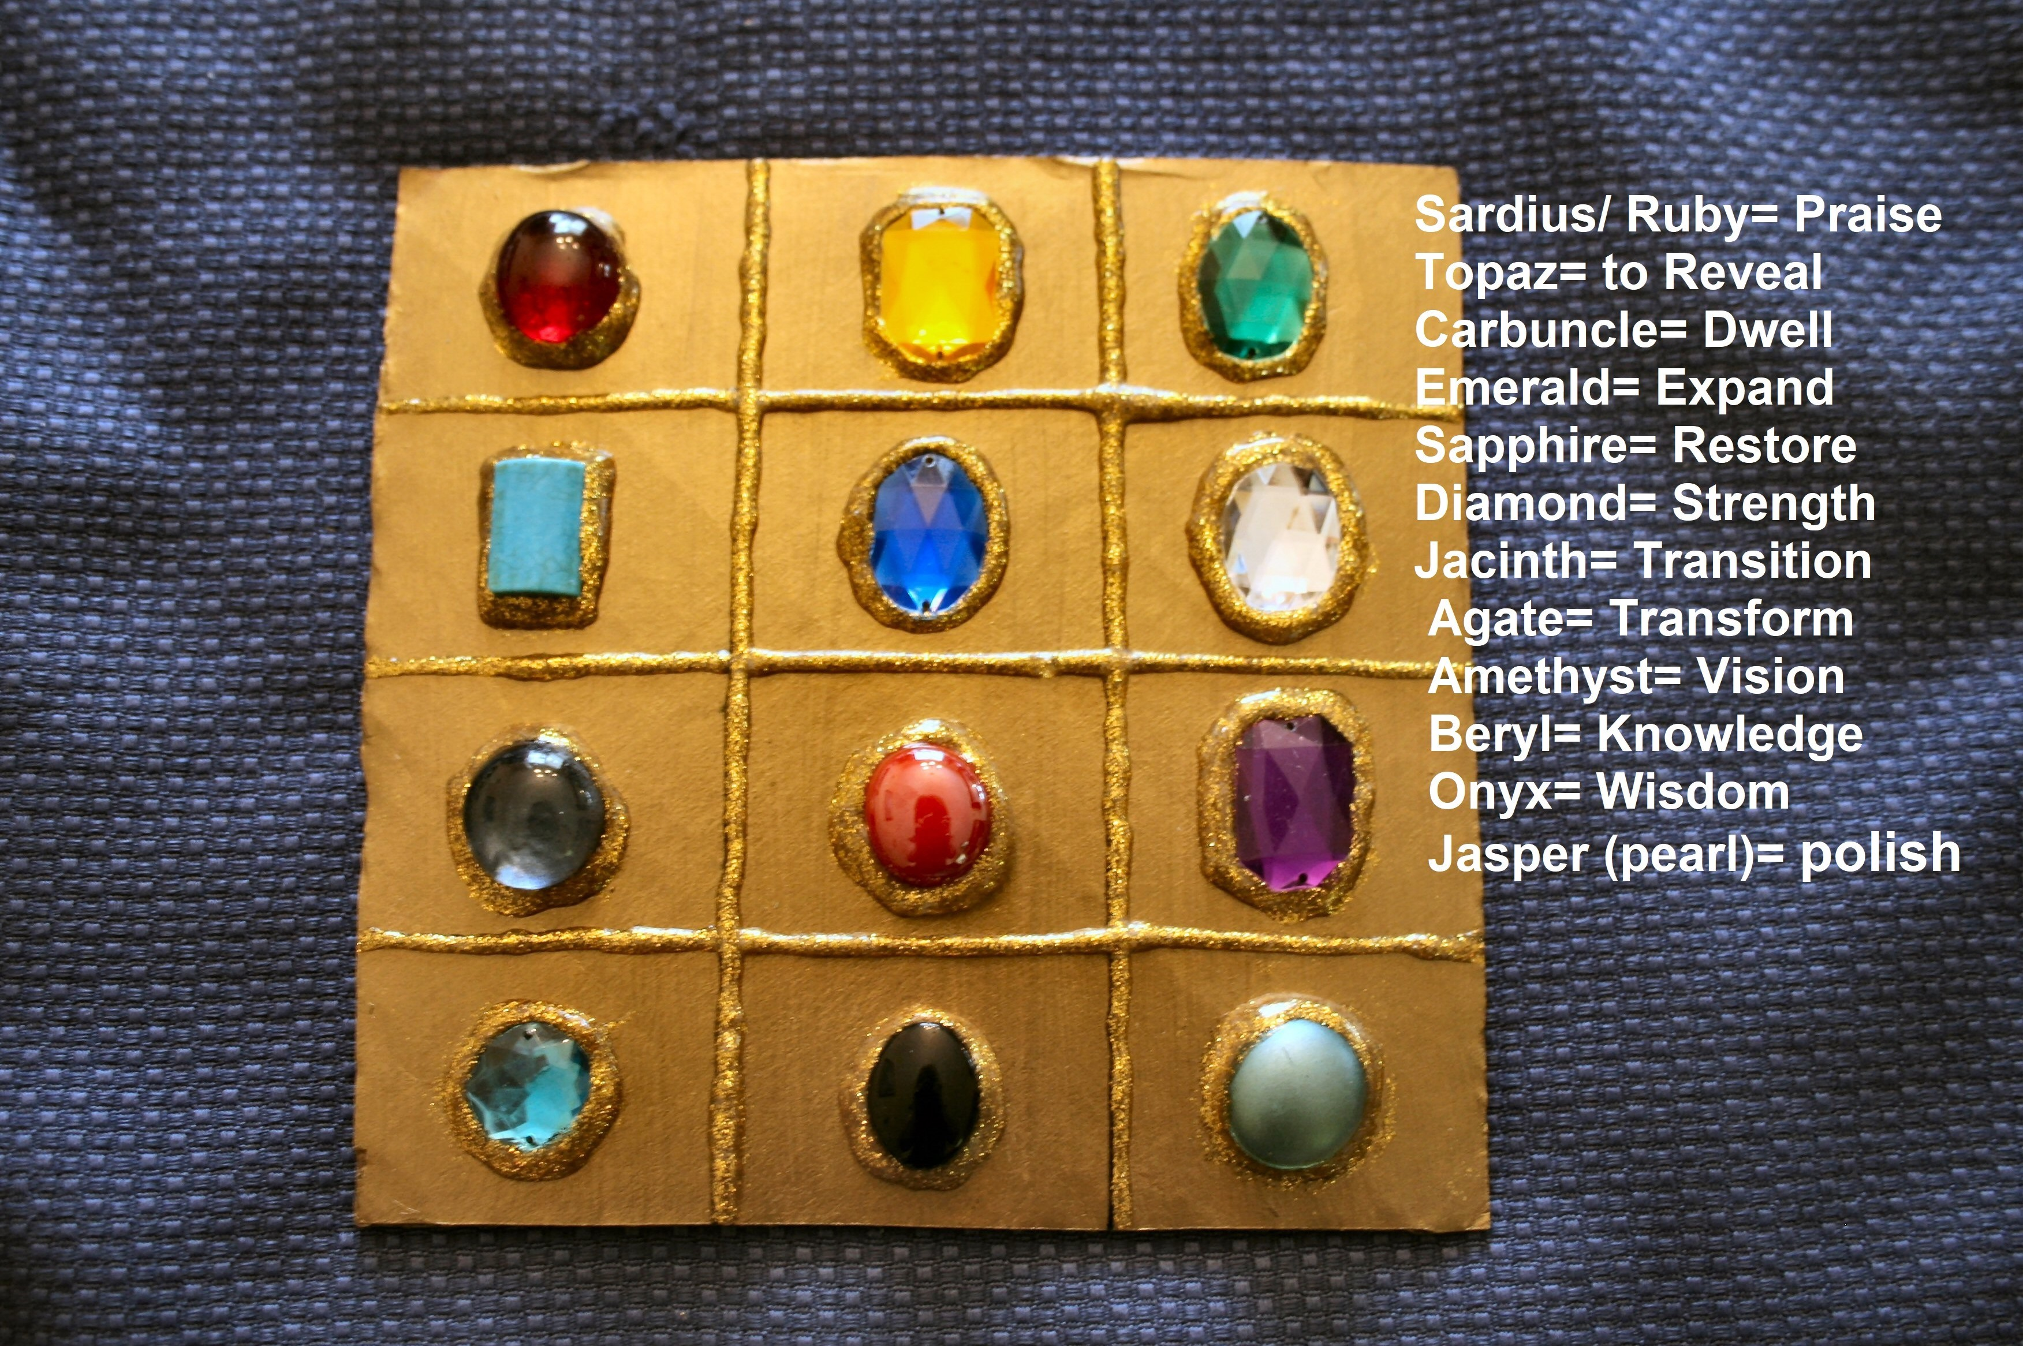

rist

