
Mentor School of Ministry

Dr Rick Kendall, Teacher
Phone: 772-979-3409 E-mail: drrickkendall@outlook.com

Descriptions of the workings & outcomes of this seminar class.

Interactive

Dialogue

Discovery

Researching

Revelation

Transition

Process

Potential

Activation

Change

Jesus is Lord!

Course: New Heavens & New Earth
Class #1: Introduction: The Economics of The NEW Jerusalem

Revelation 21:10 ¹⁰And he carried me away in the Spirit to a mountain great and high, and showed me the Holy City, Jerusalem, coming down out of heaven from God.

NEW: Gr. kainos: original blueprint / unprecedented/ day revealed
JERUSALEM: Heb. Yeruwshalaim Gr. ierousalēm City SET in PEACE/ the Base & Center of God’s government/ order/ rule

- The New BEGINS: the Garden of Eden (PLEASURE) emerges

  - Genesis 2:8 ⁸And the LORD God planted a garden eastward in Eden; and there he put the man whom he had formed. (Note: the garden was IN EDEN)
  - Genesis 1:28 ²⁸And God blessed them, and God said unto them, Be fruitful, and multiply, and replenish the earth, and subdue it: and have dominion over the fish of the sea, and over the fowl of the air, and over every living thing that moveth upon the earth.
  - Genesis 2:9 ⁹And out of the ground made the LORD God to grow every tree that is pleasant to the sight, and good for food; the tree of life also in the midst of the garden, and the tree of knowledge of good and evil.
  - God set man as STEWARDS of HIS economy & real estate. Man took ownership.

- The NEW RESTORED: Jerusalem (PEACE) the great City descends

  - Descend: Gr. katabainō ENTRY: stepping back into the prepared territory
  - Description: we cannot think in terms of conventional construction
  - The 12 tribe names on gates/ the 12 apostle names in the foundation (is not about glorifying them or their names, but represent their role to restore His blueprint.)
  - Revelation 21:18-21, And the building of the wall of it was of jasper: and the city was pure gold, like unto clear glass. And the foundations of the wall of the city were garnished with all manner of precious stones….(listed in verse) And the twelve gates were twelve pearls: every several gate was of one pearl: and the street of the city was pure gold, as it were transparent glass. NOTE: every aspect processed to perfection.
  - NOTE: The WALL (represents blueprint/ foundations), the GATES (represent governmental process/ entry), and the STREET (singular) (represents designation & destination fulfilled).
  - Revelation 22:2 ²In the midst of the street of it, and on either side of the river, was there the tree of life, which bare twelve manner of fruits, and yielded her fruit every month: and the leaves of the tree were for the healing of the nations.

- The NEW in PROCESS: The CHURCH (Kingdom representatives) arises

  - NOTE: Revelation 21:10, he was carried him to a high mountain, (to get a better view? No) but because mountains also represent spheres/ realms/ territory
  - Mountains begin as hills: Matthew 5:14; Ye are the light of the world. A city that is set on an hill cannot be hid. (we are the NEW JERUSALEM in process of PEACE!
  - Micah 4:1:But in the last days it shall come to pass, that the mountain of the house of the LORD shall be established in the top of the mountains, and it shall be exalted above the hills; and people shall flow unto it.
  - Ephesians 2:19-22 ¹⁹Now therefore ye are no more strangers and foreigners, but fellow-citizens with the saints, and of the household (economy) of God; ²⁰And are built upon the foundation of the apostles (architects) and prophets (contractors), Jesus Christ himself being the chief corner stone (blueprint); In whom all the building fitly framed together groweth unto an holy temple in the LORD: In whom ye also are builded together for an habitation of God through the Spirit.
  - This is why Jesus said: Upon THIS ROCK of revelation, I will BUILD (process) MY CHURCH & give you the KEYS of the KINGDOM!

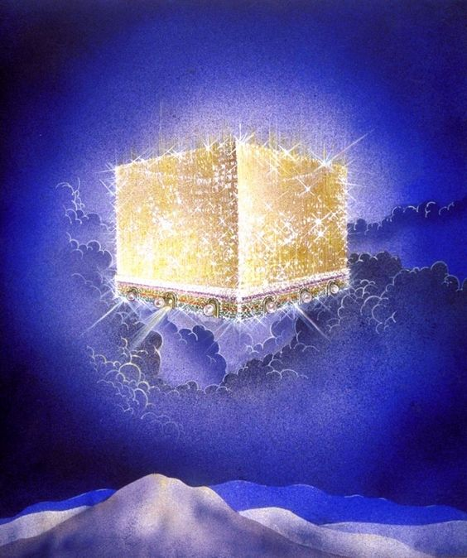

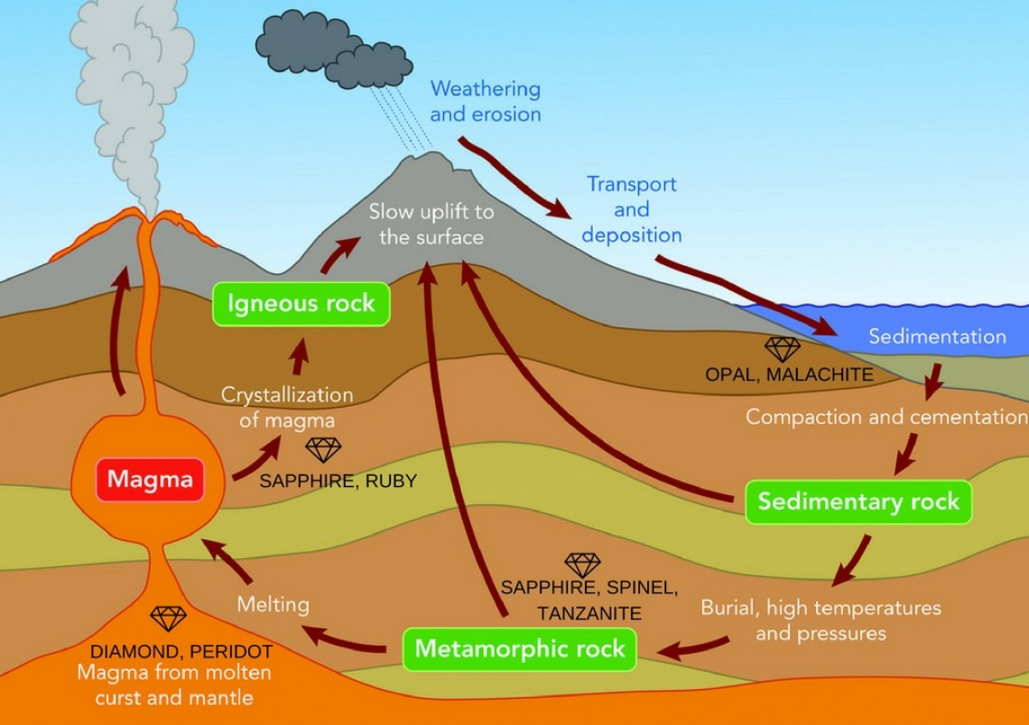

rist

