Mentor School of Ministry

Dr Rick Kendall, Teacher

Descriptions of the workings & outcomes of this seminar class.

Interactive

Dialogue

Discovery

Researching

Revelation

Transition

Process

Potential

Activation

Change
296 SE St Lucie Blvd. Stuart, Florida 34996 Phone: 772-979-3409 E-mail: DrRickKendall@outlook.com
Class Course: The 7 Churches of the Book of Revelations
Week # 2: The Church at Ephesus & Smyrna
NOTE: right after God describes the seven churches as examples of need to overcome…
Revelation 4:1, After this I looked, and, behold, a door was opened in heaven: (transition) and the first voice which I heard was as it were of a trumpet talking with me; which said, Come up hither
(level up), and I will shew thee things which must be hereafter.
While we cannot read all of Revelation chronologically, we can when it says “After this”
So why would the Spirit of God admonish the church where they need improvement to overcome and then take them immediately out to heaven? The goal is not to escape but to OVERCOME!
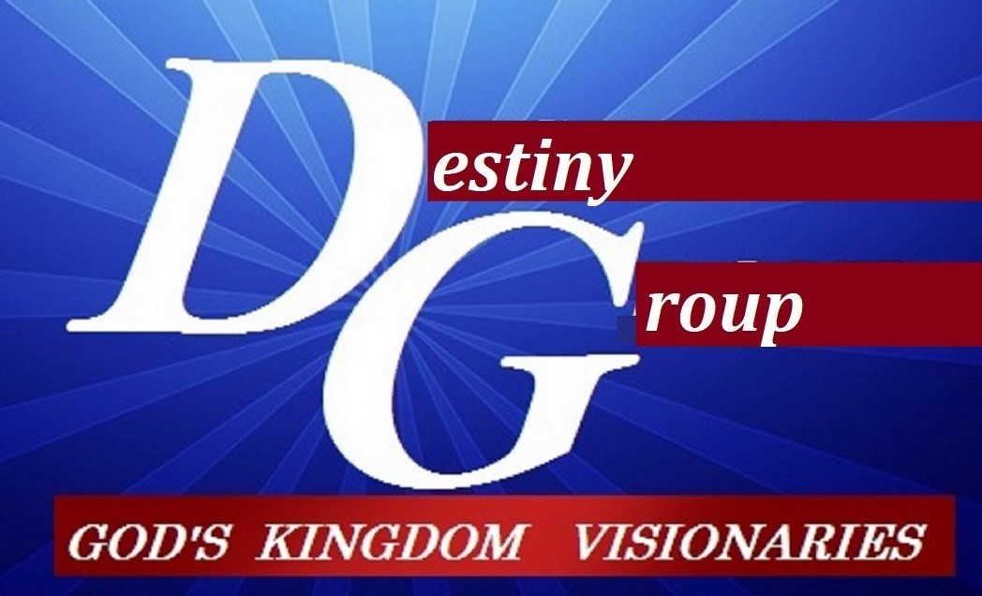

He speaks to the CHURCHES: Gr. ekklēsia called out/ ambassadors/ embassy Authorized to be the Body of Him that opens seals/ sounds trumpets/ pours vials

- Ephesus: Religious: regulatory strong but weak in love/ joining religions

  - Rev.2:2, I know thy works, and thy labour, and thy patience, and how thou canst not bear them which are evil: and thou hast tried them which say they are apostles, and are not, and hast found them liars: And hast borne, and hast patience, and for my name's sake hast laboured, and hast not fainted. Nevertheless I have somewhat against thee, because thou hast left thy first love.
  - They became obsessed with focusing on correcting the issues, but forgot their 1st love and became the reactionary to issues, but only wore God’s Kingdom mandate as a token.
  - Ephesus was an emerging inventive region, but filled with idolatry. It was where the temple of Diana was located (goddess of hunting/ ambition & the moon/ false light/ wearer of token jewelry) in league with Nimrod (called a sun god) who tried to build Babel (dedicated to Baal).
  - In a sense the church (divided) left their Kingdom mandate to battle what God already defeated.
  - Matthew 22:37-40 Jesus said unto him, Thou shalt love the Lord thy God with all thy heart, and with all thy soul, and with all thy mind. This is the first and great commandment. And the second is like unto it, Thou shalt love thy neighbour as thyself. On these two commandments hang all the law and the prophets.
  - Rev. 2:7, He that hath an ear, let him hear what the Spirit saith unto the churches; To him that overcometh will I give to eat of the tree of life (not the tree of good and evil), which is in the midst of the paradise of God (original design-Kingdom of heaven)

- Smyrna: Relationship: rich yet considered poor/ persecuted but powerful

  - Revelation 2:8-9 And unto the angel of the church in Smyrna write; These things saith the first and the last, which was dead, and is alive; I know thy works, and tribulation, and poverty, (but thou art rich) and I know the blasphemy of them which say they are Jews (familiarity of kinship but have ulterior motives), and are not, but are the synagogue (assembly/ congregation/ united in constructed lies) of Satan.
  - Smyrna: The Business, trade, and marketing capital, (mammon over manna)
  - Rev.2:10, Fear none of those things which thou shalt suffer: behold, the devil shall cast some of you into prison (seeking to keep you captive until you buy into his lies), that ye may be tried; and ye shall have tribulation ten days (meaning a short time): be thou faithful unto death (no dependency on surviving through compromise), and I will give thee a crown (exalted rank of authority & royalty) of Kingdom life. (applicable here on earth not just heaven)
  - Rev. 2:11, He that hath an ear, let him hear what the Spirit saith unto the churches; He that overcometh shall not be hurt of the second death (missed eternal purpose/ unfulfilled

- Summary: two distinct aspects of corrupted world systems already OVERCOME

  - Principalities: false gods/ religions/ control/ illegal governments (Ephesus)
  - Powers: media/ medical (misappropriation)/ mammon/ man’s (governmental systems)
  - Colossians 2:15, And having spoiled principalities and powers, he made a shew of them openly, triumphing over them in it. (the illegal prince & his principality has been defeated)
  - John 16:33, These things I have spoken unto you, that in me ye might have peace. In the world ye shall have tribulation: but be of good cheer; I have overcome (Gr. nikao: subdued victoriously) the world (systems).
NOTES:_________________________________________________________________________________________________________________________________________________________________________________________________________________________________________________________________________________________________________________________________________________________________________________________________________________________________________________________________________________________________________________________________________________________________________________________________________________________________________________________________________________________________________________________________________________________________________________________________________________________________________________________________________________________________________________

