Mentor School of Ministry

Dr Rick Kendall, Teacher

Ephesians 4:11-14: And he gave some, apostles; and some, prophets; and some, evangelists; and some, pastors and teachers;
¹² For the perfecting of the saints, for the work of the ministry, for the edifying of the body of Christ:
¹³ Till we all come in the unity of the faith, and of the knowledge of the Son of God, unto a perfect man, unto the measure of the stature of the fulness of Christ:
¹⁴ That we henceforth be no more children, tossed to and fro, and carried about with every wind of doctrine, by the sleight of men, and cunning craftiness, whereby they lie in wait to deceive;

296 SE St Lucie Blvd. Stuart, Florida 34996 Phone: 772-979-3409 E-mail: DrRickKendall@outlook.com
Class Course: The 7 Churches of the Book of Revelations
Week # 4:The Church of the Laodiceans & How a Church Get’s Messed Up

Revelation 3:14, And unto the angel of the church of the Laodiceans write; These things saith the Amen, the faithful and true witness, the beginning of the creation of God
NOTE: The Amen (I AM-So Be It)-(faithful & true witness-the beginning of the creation)

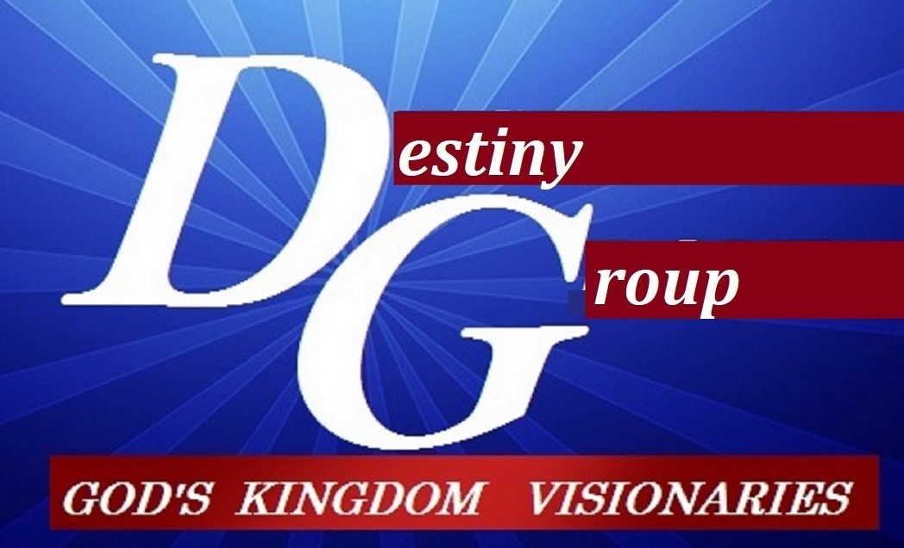

- The Matter of the Laodiceans: Physical Strength & Fashion Became Their Source

  - The Apostle Paul related often of his love and concern for the Laodicean church.
  - Laodicea was a city rich in trade, wealth and expert in the dying of fabrics (black wool). It was a pleasure resort for the physically strong and prosperous, and a health resort.
  - Laodicea means “rule of the people (they had become a democratic run church.
  - Wealth (resources) & status became their “source”. God’s Kingdom became an ornament.

- The Mess at the Laodicean church: Purpose & Potential Was Traded For Mediocrity

  - (v.15) I know thy works, that thou art neither cold nor hot: I would thou wert cold or hot.
(v.16) So then because thou art lukewarm, and neither cold nor hot, I will spue thee out of my mouth. (Spue: Gr. emeo: regurgitate-reject, indigestible) (Mouth: Gr. stoma-processing Word)
  - (v.17 Because thou sayest, I am rich, and increased with goods, and have need of nothing; and knowest not that thou art wretched, and miserable, and poor, and blind, and naked:
  - (v.18) I counsel thee to buy of me gold tried in the fire, that thou mayest be rich; and white raiment, that thou mayest be clothed, and that the shame of thy nakedness do not appear; and anoint thine eyes with eyesalve, that thou mayest see.
  - (v.19) As many as I love, I rebuke and chasten: be zealous therefore, and repent.
  - (v.20) Behold, I stand at the door (authorized opening), and knock (requiring response on the part of one on the other side): if any man hear my voice, and open the door, I will come in to him (have interaction), and will sup with him, and he with me. (He is the voice and the door)
  - John 10:9, I am the door: by me if any man enter in, he shall be saved, and shall go in and out, and find pasture. (Note: Jesus is not standing outside/ He’s inside & the Laodiceans outside.
  - (v.21) To him who overcomes I will grant to sit with Me on My throne (rule/ order/ government), as I also overcame and sat down with My Father on His throne.

- The Message to the 7 Churches: Get My House In Order To Rule & Reign

  - In every church God speaks to the angels (ministers) leading and who are responsible.
  - We’ve been out of order in function: (those set in the order of God’s Kingdom.
1 Corinthians 12:28 KJV And God hath set (in order) some (officiating) in the church, first apostles, secondarily prophets, thirdly teachers, after that (the activation of) miracles, then gifts of healings, helps, governments, diversities of tongues
  - The Five Fold Gifts (see side panel) are not set for initiating, but equipping & activating. The 3 set are not a regulating hierarchy, but sent by process to establish & develop God’s Kingdom government into colonized territories. (whether 5 gift or 3 set, we are all sons).
  - Chapter 4:1 After this I looked, and, behold, a door was opened in heaven: (not to escape, but to enter into the next level of the church’s assignment) and the first voice which I heard was as it were of a trumpet talking with me; which said, Come up hither, and I will shew thee things which must be hereafter. (THE DOOR IS ACTIVATED OPEN EVEN NOW!)
  - Some of the current issues in churches today…
    - Ephesus: Religious doctrine, Parasitical regulation, Denominational supremacy
    - Smyrna: Fear of standing in the arenas of opposition
    - Pergamos: Compromise and mixture to appease & draw crowds
    - Thyatira: In the name of love are gullible to false prophets & charlitans
    - Sardis: Assume what they’ve accomplished will give them greater spirituality
    - Philadelphia: Kept the protocol of Kingdom purpose/ I set an open door
    - Laodicea: Making the resources of wealth status your riches, you are blind
WHEN WE OVERCOME WE COME OVER TO IMPACTING THE WORLD
NOTES_______________________________________________________________________________________________________________________________________________________________________________________________________________________________________________________________________________________________________________________________________________________________________________________________________________________________________________________________________________________________________________________________________________________________________________________________

