Dr. Rick Kendall Teacher

Mentor School

Dr Rick Kendall, Teacher

Descriptions of the workings & outcomes of this seminar class.

Interactive

Dialogue

Discovery

Researching

Revelation

Transition

Process

Potential

Activation

Change

296 SE St Lucie Blvd. Stuart, Florida 34996 Phone: 772-979-3409
E-mail: DrRickKendall@outlook.com
Class Course: The 7 Churches of the Book of Revelations
Week # 7:Hear What the Spirit is Saying to the Churches

Revelation 2:7a, He that hath an ear (receptivity), let him hear (understand) what the
Spirit (Gr. pneuma: 3rd person, Life of Truth) saith (Gr. lego: specific teaching as to decree)
unto the churches… Spirit: (Heb. Ruah: breath/ wind/ the life to the mind)
Often in religious traditions, God’s Spirit was treated as an emotional jump start battery, a visitor for revivals, a publicity agent for mircles, signs and wonders, a consoler in difficult times, or a super power for achieving occasional great feats.
Comforter: Gr. parakletos: come-fortress/ advocate/ intercessor/ to stand alongside to reinforce.
The Kingdom of God is His government and has a Governor= Extension of His governance
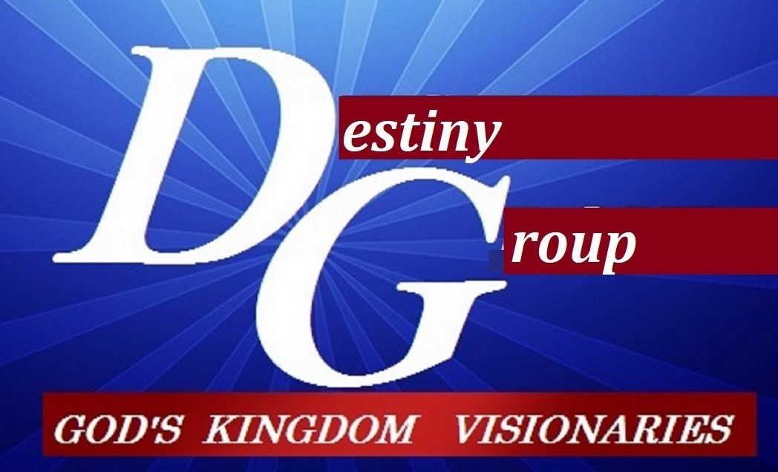

- EXTENSION: of the King to order the life of His Kingdom IN THE EARTH

  - Jesus, the Word made flesh, first born of many brethren, legally restored connection to God.
  - John 16:7-8, Nevertheless I tell you the truth; It is expedient for you that I go away: for if I go not away, the Comforter will not come unto you; but if I depart, I will send him unto you. And when he is come, he will reprove the world of sin, and of righteousness, and of judgment: (NOTE: this is the same Spirit that is speaking to the churches)
  - John 16:13-14, Howbeit when he, the Spirit of truth, is come, he will guide you into all truth: for he shall not speak of himself; but whatsoever he shall hear, that shall he speak: and he will shew you things to come (the prophetic nature of God). He shall glorify me: for he shall receive of mine, and shall shew it unto you. (He teaches by transformation)
  - The same Spirit that hovered and dived down into creation at God’s Word is in us!

- EXPANSION: colonization through God’s Embassies to bring cultivation of ORDER

  - The habitation of the Spirit (is about our BEING under AUTHORITY to Operate). It’s the character of the House in us that sets the order of fruit & gifts)
  - Eph. 2:22 In Whom ye are builded together for an HABITATION of God THROUGH the Spirit. (The Spirit of God is the CONDUCTOR (the order of producing LIFE!)
1 Corinthians 12:4-6;
- Diversities of gifts but the same Spirit (ANOINTING) motivational
- Differences of Administrations (offices) same Lord (APPOINTING) positional
- Diversities of Operations but the same God (ASSIGNMENTS). functional
  - The fruit of the Spirit (is about CULTIVATION & PRODUCING)…flows from the character of the House Gal.5:22,23 love, joy, peace, longsuffering, gentleness, goodness, faith, meekness, temperance.
  - The gifts of the Spirit (is about RELEASING)…flows through the fruit
  - Power to KNOW: word of wisdom, word of knowledge, discerning of spirits
  - The Power to ACTIVATE: faith, gifts of healing, working of miracles.
  - The Power to SPEAK: prophecy, divers kinds of tongues, interpretation of tongues
Signs follow us, we don’t follow signs. Kingdom Culture impacts the world (unbeliever) resulting in manifestations… Miracles: (shifting of atmosphere) WHAT, Signs: (significant revelations) WHY, Wonders: (introducing the sights & sounds of change) HOW

- EXCELLENCE: beyond repeating the past but revealing what’s been done.

  - The Spirit of God sets, shapes and shifts every season into advancing the Kingdom
  - Remember: We have an environment inside us producing an atmosphere around us governed by the Spirit (to cultivate Kingdom life)
  - The ecosystem of the Spirit involves wind (breath) water (nourishment) fire (refining) and light (expansion) as the Word is cultivated into us and then into the world
  - Matthew 5:14-16, Ye are the light of the world. A city that is set on an hill cannot be hid.
  - Revelation 22:17, And the Spirit and the bride say, Come. And let him that heareth say, Come. And let him that is athirst come. And whosoever will, let him take the water of life freely.
NOTES_______________________________________________________________________________________________________________________________________________________________________________________________________________________________________________________________________________________________________________________________________________________________________________________________________________________________________________________________________________________________________________________________________________________________________________________________

