

Dr Rick Kendall, Teacher

Descriptions of the workings & outcomes of this seminar class.

Revelation

Transition

Process

Potential

Activation

Change

Jesus is Lord!

Phone: 772-979-3409, E-mail: drrickkendall@outlook.com
Course Series: All Creation Is Waiting
Class 6: First-fruits of His Creation
James 1:18, Of His own will begat (birthed a new succession line of SEED) He us with the word of truth, that we should be a kind of first-fruits of His creatures. (regenerating the original design in Him)

Firstfruits: Gr. Aparche: birthing new beginning, the “arch” of new seed succession, first as in original generation regenerating progressive generations to come. Eternal purpose births through Kairos time.

- EXALTATION: Eternal Purpose Through the Process of Kairos Time (tapestry)
  - All creation is waiting but represented before God’s throne as living creatures.
  - Isaiah 1:15-16, Now as I beheld the living creatures, behold one wheel upon the earth by the living creatures, with his four faces. ¹⁶ The appearance of the wheels and their work was like unto the colour of a beryl: and they four had one likeness: and their appearance and their work was as it were a wheel in the middle of a wheel. (depicting process and progress)
  - Isaiah 6:2-3, Above it stood the seraphims: each one had six wings; with twain (two) he covered his face (countenance), and with twain (two) he covered his feet (progress), and with twain (two) he did fly (potential awaiting fulfillment). ³ And one cried unto another, and said, Holy, holy, holy, is the Lord of hosts: the whole earth is full of his glory. (Seraphims worship God’s holiness continually).
  - Ezekiel 1:10, As for the likeness of their faces, they four had the face of a MAN, and the face of a LION, on the right side: and they four had the face of an OX on the left side; they four also had the face of an EAGLE. (4 faces on each creature depicting simultaneous tapestry unfolding in time)
  - Revelation 4:6-7, And before the throne there was a sea of glass like unto crystal: and in the midst of the throne, and round about the throne, were four beasts full of eyes (discernment & perception) before and behind. ⁷ And the first beast was like a LION, and the second beast like a CALF, and the third beast had a face as a MAN, and the fourth beast was like a flying EAGLE. (NOTE: now the distinction of four separate creatures depicts activation)
  - Revelation 5:6, And I beheld, and, lo, in the midst of the throne and of the four beasts, and in the midst of the elders, stood a LAMB as it had been slain, having seven horns and seven eyes, which are the seven Spirits of God sent forth into all the earth.

- EXPECTATION Through Manifestation of Restoration (bringing refining fire)
a. Lion. Power of Kingship through Sonship. MOUTH (voice/ royal roar of authority)
b. Ox. Ploughing new ground, yoke is easy, burden light. FEET
c. Eagle. Potential & discernment, VISION
d. Man. Purpose & Representatives of God as stewards as first-fruit representations to restore. HANDS
e. Romans 8:19, For the earnest expectation (the pressing anticipation) of the creature
waiteth for the manifestation of the sons of God.
f. MANIFESTATION: Gr. Apokalypsis: revelation of God’s Kingdom fully restored!

- REGENERATION Eternal Purpose Birthed the Process of Kairos Time (tapestry)
  - Romans 8:29, For whom he did foreknow, he also did predestinate to be conformed to the image of his Son, that he might be the FIRSTBORN (prototype) among many brethren.
  - Christ restored the LEGACY of His Father in mankind to birth NEW CREATURES
  - Colossians 1:15, Who is the image of the invisible God, the firstborn of every creature:
  - We as the FIRSTFRUITS of creation return to the stewardship of creation to restore all to God who owns it all.
  - Proverbs 3:9, Honour the Lord with thy substance, and with the firstfruits of all thine increase:
NOTES:____________________________________________________________________________________________________________________________________________________________________________________________________________________________________________________________________________________________________________________________________________________________________________________________________________________________________

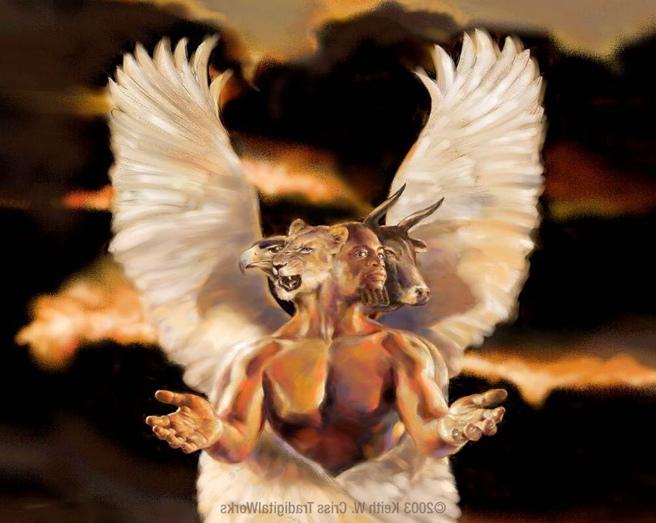

rist
__

