
Mentor School of Ministry

Dr Rick Kendall, Teacher

Descriptions of the workings & outcomes of this seminar class.

Interactive

Dialogue

Discovery

Researching

Revelation

Transition

Process

Potential

Activation

Change

Jesus is Lord!

296 SE St Lucie Blvd. Apt. 202, Stuart, Fl. 34996 Phone: 772-979-3409
E-mail: drrickkendall@outlook.com

Course: Growing Into God’s Kingdom Maturity
Class #2: The Crown of Life
James 1:12, Blessed is the man that endureth temptation (Gr. Peirasmos: tests of character): for when he is tried, he shall receive the crown of life, which the Lord hath promised to them that love Him. (2 Timothy 4:8 calls it a crown of righteousness, 1 Peter 5:4, calls it a crown of glory.)
Crown: Heb. Nezer / Atara: Separation, Consecration to, mark of royal potential, fulfilled legacy.
Crown: Gr. Stephanos: An emblem of honor, not an AWARD but a developing REWARD.
Diadem: Heb. Sepira: a crown in process: encompassing the progress of life
Isaiah 62:3, shalt also be a crown of glory in the hand of the LORD, and a royal diadem in the hand of thy God.
In the Kingdom of God a crown is already set by Name but in development by activation.

- SET: God is cultivating our CROWN by how we grow into His Image (character)

  - The CROWN and DIADEM (encircling application)-(literally a MINDSET of the HEART) are in the HAND of the King (Isaiah 62:3)
  - 1 Corinthians 2:16 ¹⁶For who hath known the mind of the LORD, that he may instruct him? but we have the mind of Christ.
  - Crown= designated mark of honor, position, not an AWARD for doing but a developing REWARD of being in His process of purpose.
  - 1 Corinthians 9:25 ²⁵And every man that striveth for the mastery is temperate in all things. Now they do it to obtain a corruptible crown; but we an incorruptible.

- STONED: The Crown reveals the Treasure once Hidden Now Manifested

    - Zechariah 9:16 ¹⁶And the LORD their God shall save them in that day as the flock of his people: for they shall be as the stones of a crown, lifted up as an ensign upon his land.
    - Not only do we wear crowns, but we are crowns of His glory.
    - Our life processes & reveals treasure through His Crown as royalty. 2 Corinthians 4:7, But we have this treasure in earthen vessels, that the excellency of the power may be of God, and not of us.
    - The Imperial State Crown of the King or Queen of England weighs 2 lbs 13 oz. It is framed in gold and silver having 2,873 diamonds, 273 pearls, 17 sapphires, 11 emeralds, 5 rubies including one huge ruby & one huge sapphire.
    - We as Kingdom Citizens are in process of a Crown of righteousness (tried in the Fire and refined by the Holy Spirit!)

- SCEPTRED: Activation of Kingdom Authority and Power in & Through Us

- Hebrews 1:8, But unto the Son he saith, Thy throne, O God, is for ever and ever: a sceptre of righteousness is the sceptre of thy kingdom.
- SCEPTRE: Heb. Shebet: rod, staff, mark of authority, a spear Gr. rhabdos: royal branch, offshoot, tribe, royal nation
- In every scepter is the image of the crown it represents. LEGACY not personal career.
- Proverbs 17:6, Children's children are the crown of old men; and the glory of children are their fathers.
- Crown: Legacy, Diadem: Life, and Sceptre: Legislation process = maturity
NOTES: ____________________________________________________________________________________________________________________________________________________________________________________________________________________________________________________________________________________________________________________________________________________

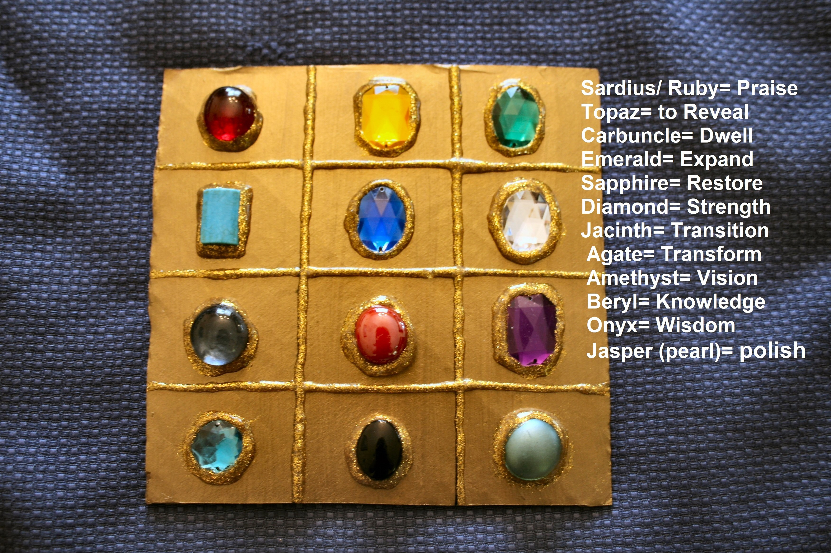

rist

